**A Project Report On**

**India Health**

**(Laboratory & Report Management System)**

**Kamani Science & Prataprai Arts Collage Amreli.**

**Developed By**

**Bosamiya Smit**

**Guide By**

**Mr. Rakesh Savaliya**

**Submitted in Partial Fulfilment of the Requirement for the Award of the Degree of Bachelor of Computer Applications (BCA).**

**Year of Submission**

**2020-2021**

**Saurashtra University – Rajkot.**

**Index**

|  |  |  |
| --- | --- | --- |
| No. | Title | Page No. |
| 1 | Preface | 1 |
| 2 | Acknowledgement | 2 |
| 3 | Abstract | 3 |
| 4 | Introduction | 4 |
| 4 | Time Line Chart | 5 |
| 6 | Project Profile | 6 |
| 7 | Hardware Requirement | 7 |
| 8 | Software Requirement | 7 |
| 9 | Requirement Specification | 8 |
| 10 | Problem Definition | 8 |
| 11 | Project Planning & Scheduling | 9 |
| 12 | System Analysis | 10 |
| 13 | Feasibility Study | 11 |
| 14 | Project Page Structure | 13 |
| 15 | Data Dictionary | 15 |

|  |  |  |
| --- | --- | --- |
| No. | Title | Page No. |
| 16 | Context Level Data Flow Diagram | 21 |
| 17 | 1st Level Data Flow Diagram | 22 |
| 18 | Use Case Diagram | 27 |
| 19 | Entity Relationship Diagram | 28 |
| 20 | Activity Diagram | 29 |
| 21 | Screenshots | 34 |
| 22 | e-Mail Samples | 53 |
| 23 | Future Scope | 55 |
| 24 | References | 56 |

**Index**

**Preface**

The Main Objective of Any Computer Science Student is to Get Practical Knowledge as Possible. Being Able to Have a Practical Knowledge by Developing a Project is a Lifetime Experience. as Practical Knowledge is Important as Theoretical Knowledge, I am Thankful of Having a Project.

Through the Development of the Project I had a Great Experience of Various Strategies that can applied in development of the Project. This Project is the Stepping Stone for My Career.

I am Pleased to Present this Project report. Proper Case has been taken While Organizing the report so that it is easy to comprehend. Also, various Software Engineering Concept have been implemented.

**Acknowledgement**

I am The Student of BCA sem-5 Studying in Kamani Science Collage Amreli, We Thanks to Entire Person Who Has Given Their Support in Shaping of System.

I Thanks to all Our Teachers for Giving Guidance and Cooperation in Understanding the System. I also Thanks them for Their unconditional help in making of this project.

I have great deal of gratitude towards our head of department who encourage me in taking up this activity. I thanks to all faculties and administrative staff of the institute.

Thanks to All

Bosamiya Smit

**Abstract**

My Aim is to Design and Create Data Management System for All Laboratory. This is Enables admin to Manage Laboratory Reports, it’s Units and Also Can Provide Groups and Templates to Laboratories.

**Introduction**

The Laboratory Management System Provide Facility to All Laboratories to Make and Save their Reports. Patients who are Part of this System (network) are Able to See and Print Their Report.

1. Patient Can Register it Self And Can Get Their Unique id.
2. By Login With There Username & Password They can Access Their Medical Reports from Any Where.
3. Laboratory Person Can Add New Medical Report for The Patient.
4. Doctors Are Able to view The Medical Report of Patient.

**Time Line Chart**

**Each Segment Specify a Day.**

**Project Profile**

* Project Name : India Health (Laboratory &

Report Manage System)

* Developed By : Bosamiya Smit
* Frontend : HTML, CSS, JavaScript, PHP
* Backend : PHP + MySQL
* Developing Tools : Dreamweaver or VS Code
* Operating System : Win 7 or Hire
* Computer System : Minimum 1 GHz + 1gb Ram
* Project Details : in this Laboratory Management System,

Laboratories Can Add and Manage Patients Report.

* Completion Time : 3 Months
* Guide By : Mr. Rakesh Savaliya
* Submitted to : Saurashtra University – Rajkot

**Hardware Requirements**

* 1.0+ GHz Processor
* 1+ GB of Ram
* Monitor
* Multimedia Keyboard & Mouse
* CD Drive

**Software Requirements**

* Operating System : Win7 Or Hire
* Frontend Tools : HTML, CSS, JavaScript,

jQuery

* Language Tools : PHP
* Backend Tools : MySQL
* Documentation Tools : MS Office
* Browser Specification : Chrome or Firefox

**Requirement Specification**

* MySQL RDBMS used to Maintain the All Concerned Data
* Uses Special Views to Display Data
* Display All Type of Data Using Classified Reports with Combination of Multiple Tables.
* Special Searching of Patients and Reports.
* Controlling the Information Regarding whole Website.

**Problem Definition**

* Make Reports Definition More Flexible.
* Make Units, Groups and Templates Easy to Customisable
* Manage Reports and Its Results
* Give Good Report Creating and Management for Laboratories.
* Patient Can Easy to Access Their Reports.
* Maintain Report Privacy.
* Maintain Users Reviews and Queries.

**Project Planning & Scheduling**

For Laboratories is Very Tough to Manage Patients Reports, Create Copy of The Report and Save For Later Usage, As Well Patients Need to Carry Their Reports to Show the doctors and Need to Take Care of Them. Also, there is Some Desktop Software are Available, from Which Laboratories Can Manage Their Reports. But They Cost High and Not Much Flexible. Bring Every Kind of Participants in One Place is a Big Thing indeed.

Before Selecting of This Subject, I Have Found its Routine and most Common Problems Like Medical Reports Are Not Every Time Accessible by Particular Doctors, also a Patient Self Can’t Get Their Report Back After Lost it. It’s Very Time Consuming for Patients to Wait for Its Report in This Digital World. Also, a Doctor need a Facility to View Medical History of Patient. I hope The Project itself Says More. The Scheduling is given as Under.

**System Analysis**

System Analysis is The Process of Identification od Objectives and Requirements, Evolution of Alternative Solutions and Recommendation for a more feasible Solution.

In Other Words, System Analysis is the Step by Step Process of Gathering, Recording and interpreting facts. The Main aim of Analysis is to Determine problem areas and to take solution to reduce or eliminate them.

* System Analysis itself Breaks into Two Stages:

1. **Preliminary Analysis**
2. **Detailed Analysis**

During Analysis, Data are Collected from the available Files, Decision points and transactions of the System using various tools like Data Flow Diagram (DFD).

**Feasibility Study**

A Purpose of Feasibility Study is to Check out the Possibility of a Computerized Solution to The Organization’s Observed Problem Before Very Much Money that been Spent on.

A Feasibility Study is Carried out to Select Best System That Meets Performance Requirements. Only by Spending Time to Evaluate the Feasibility do I Reduce the Chances for Embarrassment at Large Stage of The System Project.

For the Complete Feasibility Study, I need to Concentrate on Following Area.

They Are Three Areas:

1. Technical
2. Operational
3. Economical

* **Technical:**

Technical Feasibility Considers Whether the Desired Project Can be Completed Within the Framework of Available Technology, As My Project was Website Designing, this was not Much of a Problem, as Many Advanced Web-Editing Tools Are Available.

* **Operational:**

Operational Feasibility Was Done to Assure That the Product That Would be Developed Would be Used. Since a cards and gifts has to have a website of its own sooner or later, that wasn’t much of a problem.

* **Economical:**

My Website is Economically Feasible Because. I Have to Developed this Website for One Time. Only Future Enhancement is Required on the Other hand Every Client Can View This Site at Any Time or Many Time as per Their Requirements. So, the Future Economical Expenses are null. So, I can Say That This Website is Totally Economically Feasible.

**Project Page Structure**

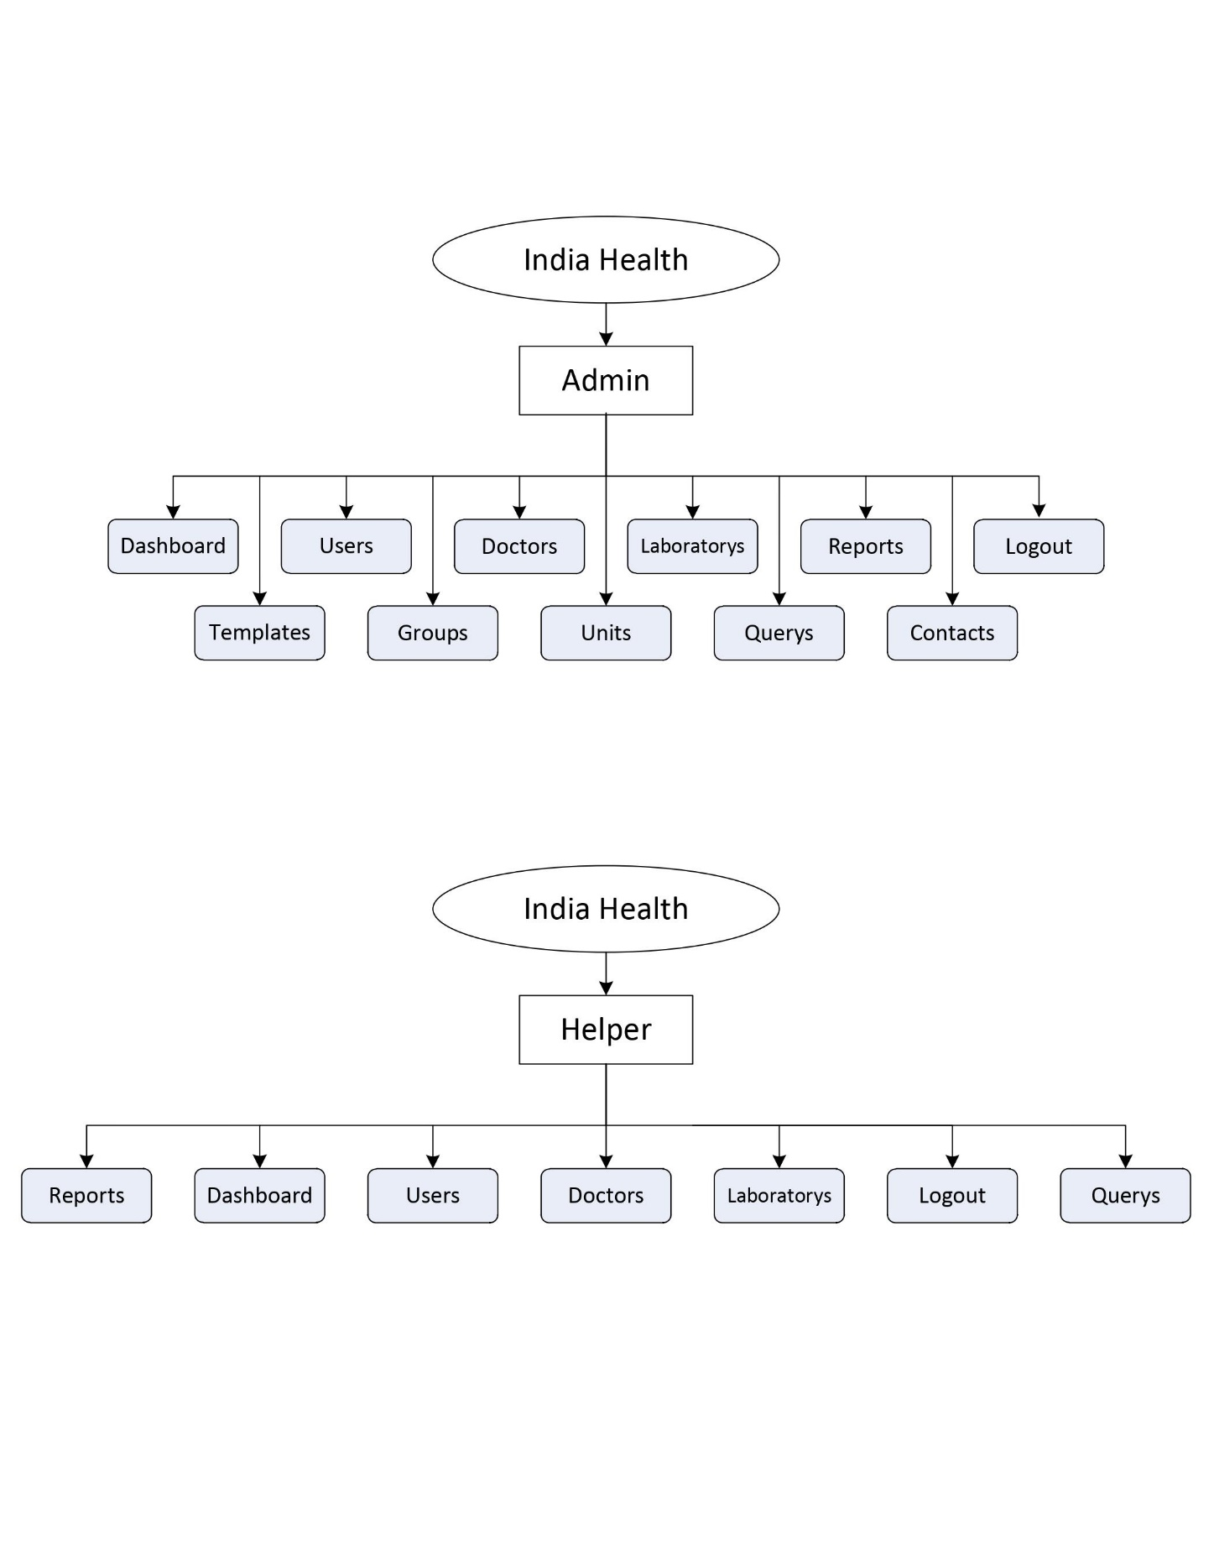

**Project Page Structure**

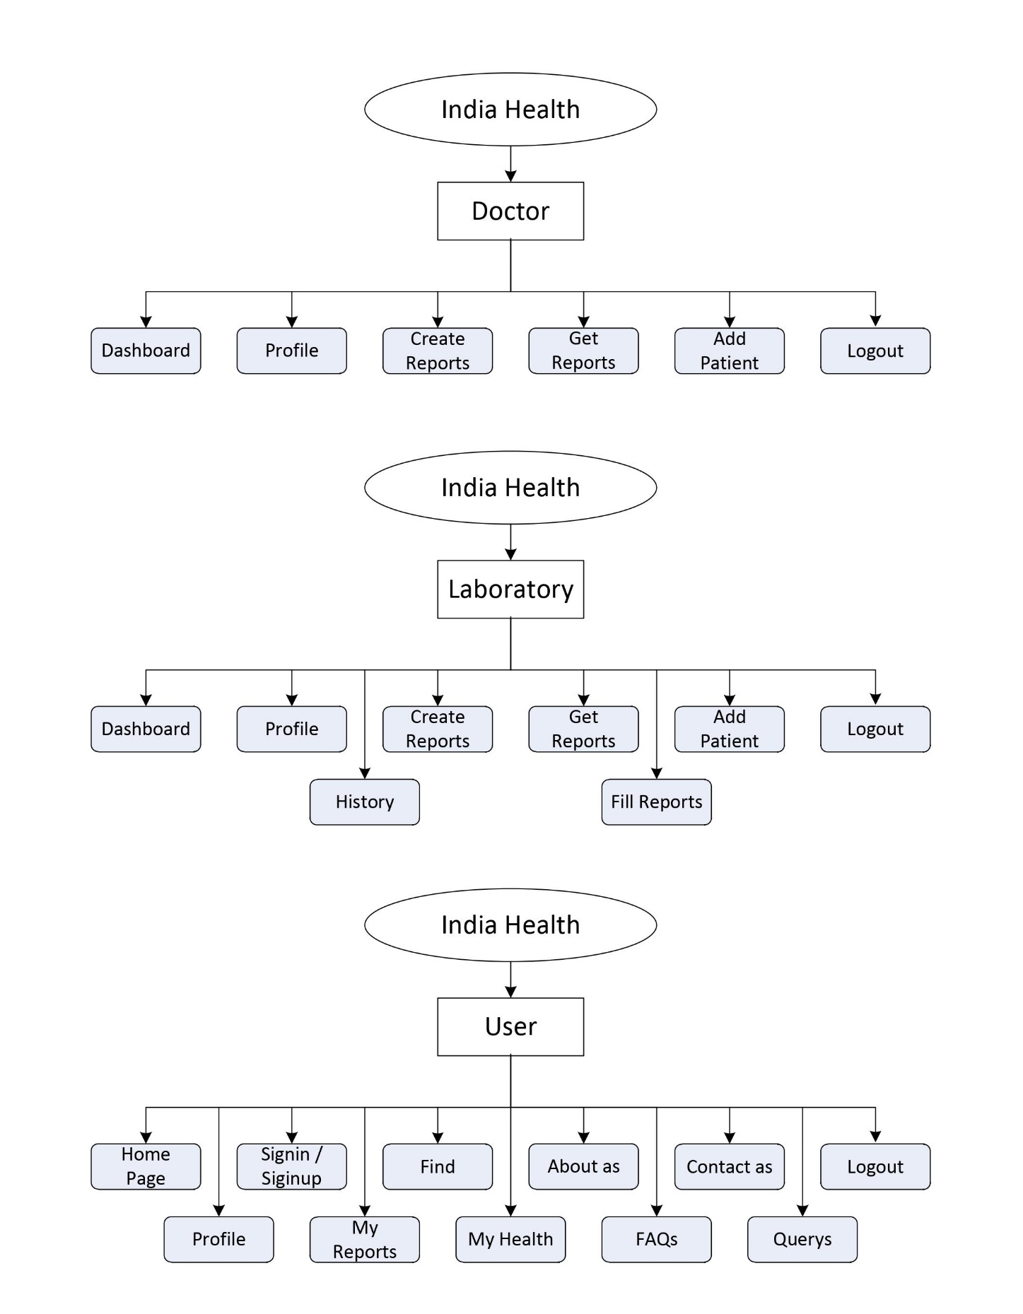

**Data Dictionary**

One Instance of Data Dictionary is a Document Describing a Database Schema for Users. In Most basic case this documentation includes descriptions of tables and their columns. We can say it is a Set of Table.

Data Dictionary can include various information about data, including relationship, constraints and rules, source and usage, to name a Few. This Documentation is used by Database Users and Developers to Understand the Data and its Structure. It Can be From of Simple Documentation or Special Repository Accessed by a Dedicated tool.

* Data Dictionary Contains the Following Information:
  + Name of The Table of Database
  + User Information Such as Privileges
  + It’s Columns name, data-types and attributes

**Database Name: Indiahealth**

**Tables is as Follows**

1. Users - Store User Information.

|  |  |  |  |
| --- | --- | --- | --- |
| **Field** | **Type** | **Default** | **Attributes** |
| user_id | int(11) | None | AUTO_INCREMENT |
| user_username | varchar(100) | None |  |
| user_name | varchar(1000) | None |  |
| user_dob | date | None |  |
| user_gender | varchar(10) | None |  |
| user_mobile | varchar(10) | None |  |
| user_email | varchar(100) | None |  |
| user_password | varchar(200) | None |  |
| user_profile | varchar(200) | None |  |
| user_admin | int(11) | 0 |  |
| user_doctor | int(11) | 0 |  |
| user_laboratory | int(11) | 0 |  |
| user_helper | int(11) | 0 |  |
| user_patient | int(11) | 1 |  |
| user_last | varchar(30) |  |  |
| user_status | int(11) | 1 |  |
| user_timestamp | timestamp | current_timestamp() |  |

1. Forgots – Password Forgot Request

|  |  |  |  |
| --- | --- | --- | --- |
| **Field** | **Type** | **Default** | **Attributes** |
| forgot_id | int(11) | None | AUTO_INCREMENT |
| forgot_user | int(11) | None |  |
| forgot_hash | varchar(500) | None |  |
| forgot_timestamp | timestamp | current_timestamp() |  |

1. Doctors – Store Doctors Information

|  |  |  |  |
| --- | --- | --- | --- |
| **Field** | **Type** | **Default** | **Attributes** |
| doctor_id | int(11) | None | AUTO_INCREMENT |
| doctor_user | int(11) | None |  |
| doctor_name | varchar(100) | None |  |
| doctor_mobile | varchar(10) | None |  |
| doctor_email | varchar(200) | None |  |
| doctor_address | varchar(500) | None |  |
| doctor_pincode | int(11) | None |  |
| doctor_recent | varchar(200) | [] |  |
| doctor_license | int(11) | 0 |  |
| doctor_status | int(11) | 0 |  |
| doctor_timestamp | timestamp | current_timestamp() |  |

1. Laboratorys – Store Laboratorys Information

|  |  |  |  |
| --- | --- | --- | --- |
| **Field** | **Type** | **Default** | **Attributes** |
| laboratory_id | int(11) | None | AUTO_INCREMENT |
| laboratory_user | int(11) | None |  |
| laboratory_name | varchar(100) | None |  |
| laboratory_mobile | varchar(10) | None |  |
| laboratory_email | varchar(200) | None |  |
| laboratory_address | varchar(500) | None |  |
| laboratory_pincode | int(11) | None |  |
| laboratory_license | int(11) | 0 |  |
| laboratory_status | int(11) | 0 |  |
| laboratory_timestamp | timestamp | current_timestamp() |  |

1. Querys – Store Patient Querys and Issues

|  |  |  |  |
| --- | --- | --- | --- |
| **Field** | **Type** | **Default** | **Attributes** |
| query_id | int(11) | None | AUTO_INCREMENT |
| query_user | int(11) | None |  |
| query_handel | int(11) | None |  |
| query_subject | varchar(300) | None |  |
| query_details | varchar(1000) | None |  |
| query_message | varchar(500) | None |  |
| query_solved | int(11) | None |  |
| query_status | int(11) | None |  |
| query_timestamp | timestamp | current_timestamp() |  |

1. Template – Store Report Template

|  |  |  |  |
| --- | --- | --- | --- |
| **Field** | **Type** | **Default** | **Attributes** |
| template_id | int(11) | None | AUTO_INCREMENT |
| template_user | int(11) | None |  |
| template_text | varchar(200) | None |  |
| template_element | varchar(5000) | None |  |
| template_status | int(1) | 1 |  |
| template_timestamp | timestamp | current_timestamp() |  |

1. Groups – Store Report Groups(Colletion of Units)

|  |  |  |  |
| --- | --- | --- | --- |
| **Field** | **Type** | **Default** | **Attributes** |
| group_id | int(11) | None | AUTO_INCREMENT |
| group_user | int(11) | None |  |
| group_text | varchar(200) | None |  |
| group_dtext | varchar(200) | None |  |
| group_unit | varchar(1000) | None |  |
| group_status | int(11) | 1 |  |
| group_timestamp | timestamp | current_timestamp() |  |

1. Units – It’s a Small Element of Any Report

|  |  |  |  |
| --- | --- | --- | --- |
| **Field** | **Type** | **Default** | **Attributes** |
| unit_id | int(11) | None | AUTO_INCREMENT |
| unit_user | int(11) | 1 |  |
| unit_text | varchar(100) | None |  |
| unit_dtext | varchar(100) | None |  |
| unit_option | varchar(500) | None |  |
| unit_symbol | varchar(25) | None |  |
| unit_range | varchar(400) | None |  |
| unit_general | int(11) | 0 |  |
| unit_status | int(11) | None |  |
| unit_timestamp | timestamp | current_timestamp() |  |

1. Reports – Store All Medical Reports

|  |  |  |  |
| --- | --- | --- | --- |
| **Field** | **Type** | **Default** | **Attributes** |
| report_id | int(11) | None | AUTO_INCREMENT |
| report_sid | varchar(20) | None |  |
| report_laboratory | int(11) | NULL |  |
| report_doctor | int(11) | NULL |  |
| report_patient | int(11) | None |  |
| report_details | mediumtext | None |  |
| report_auth | varchar(1000) | None |  |
| report_status | int(11) | 1 |  |
| report_timestamp | timestamp | current_timestamp() |  |

10. Reports – Store All Medical Reports

|  |  |  |  |
| --- | --- | --- | --- |
| **Field** | **Type** | **Default** | **Attributes** |
| contact_id | int(11) | None | AUTO_INCREMENT |
| contact_name | varchar(100) | None |  |
| contact_email | varchar(100) | None |  |
| contact_subject | varchar(100) | None |  |
| contact_message | varchar(500) | None |  |
| contact_status | int(11) | None |  |
| contact_timestamp | timestamp | current_timestamp() |  |

**Context Level Data Flow Diagram (0 Level)**

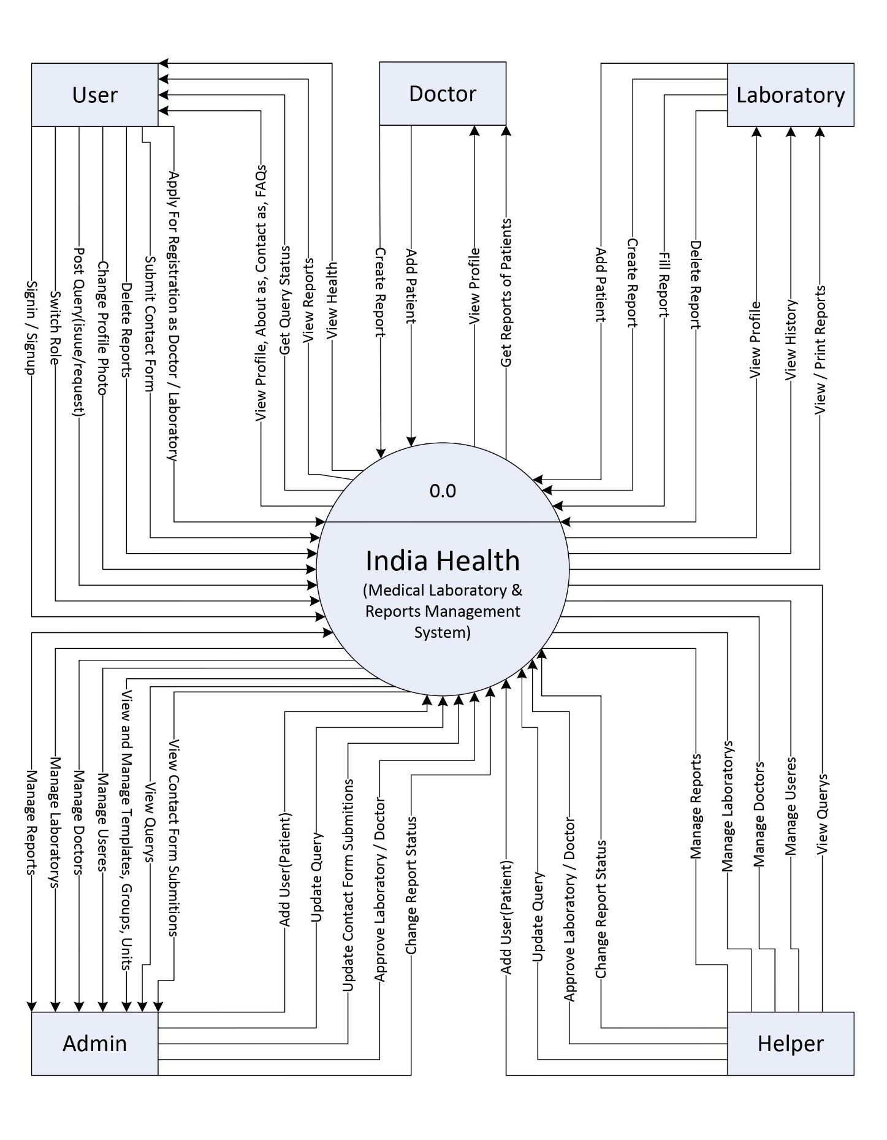

**1st Level Data Flow Diagram**

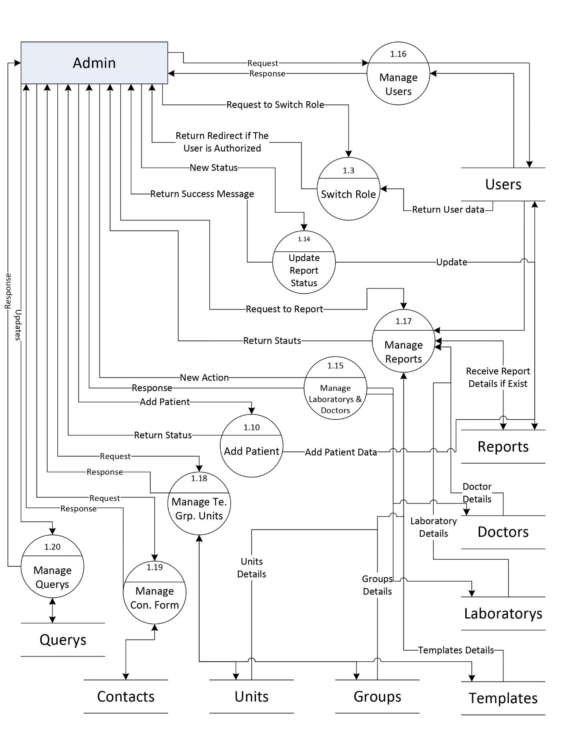

**1st Level Data Flow Diagram**

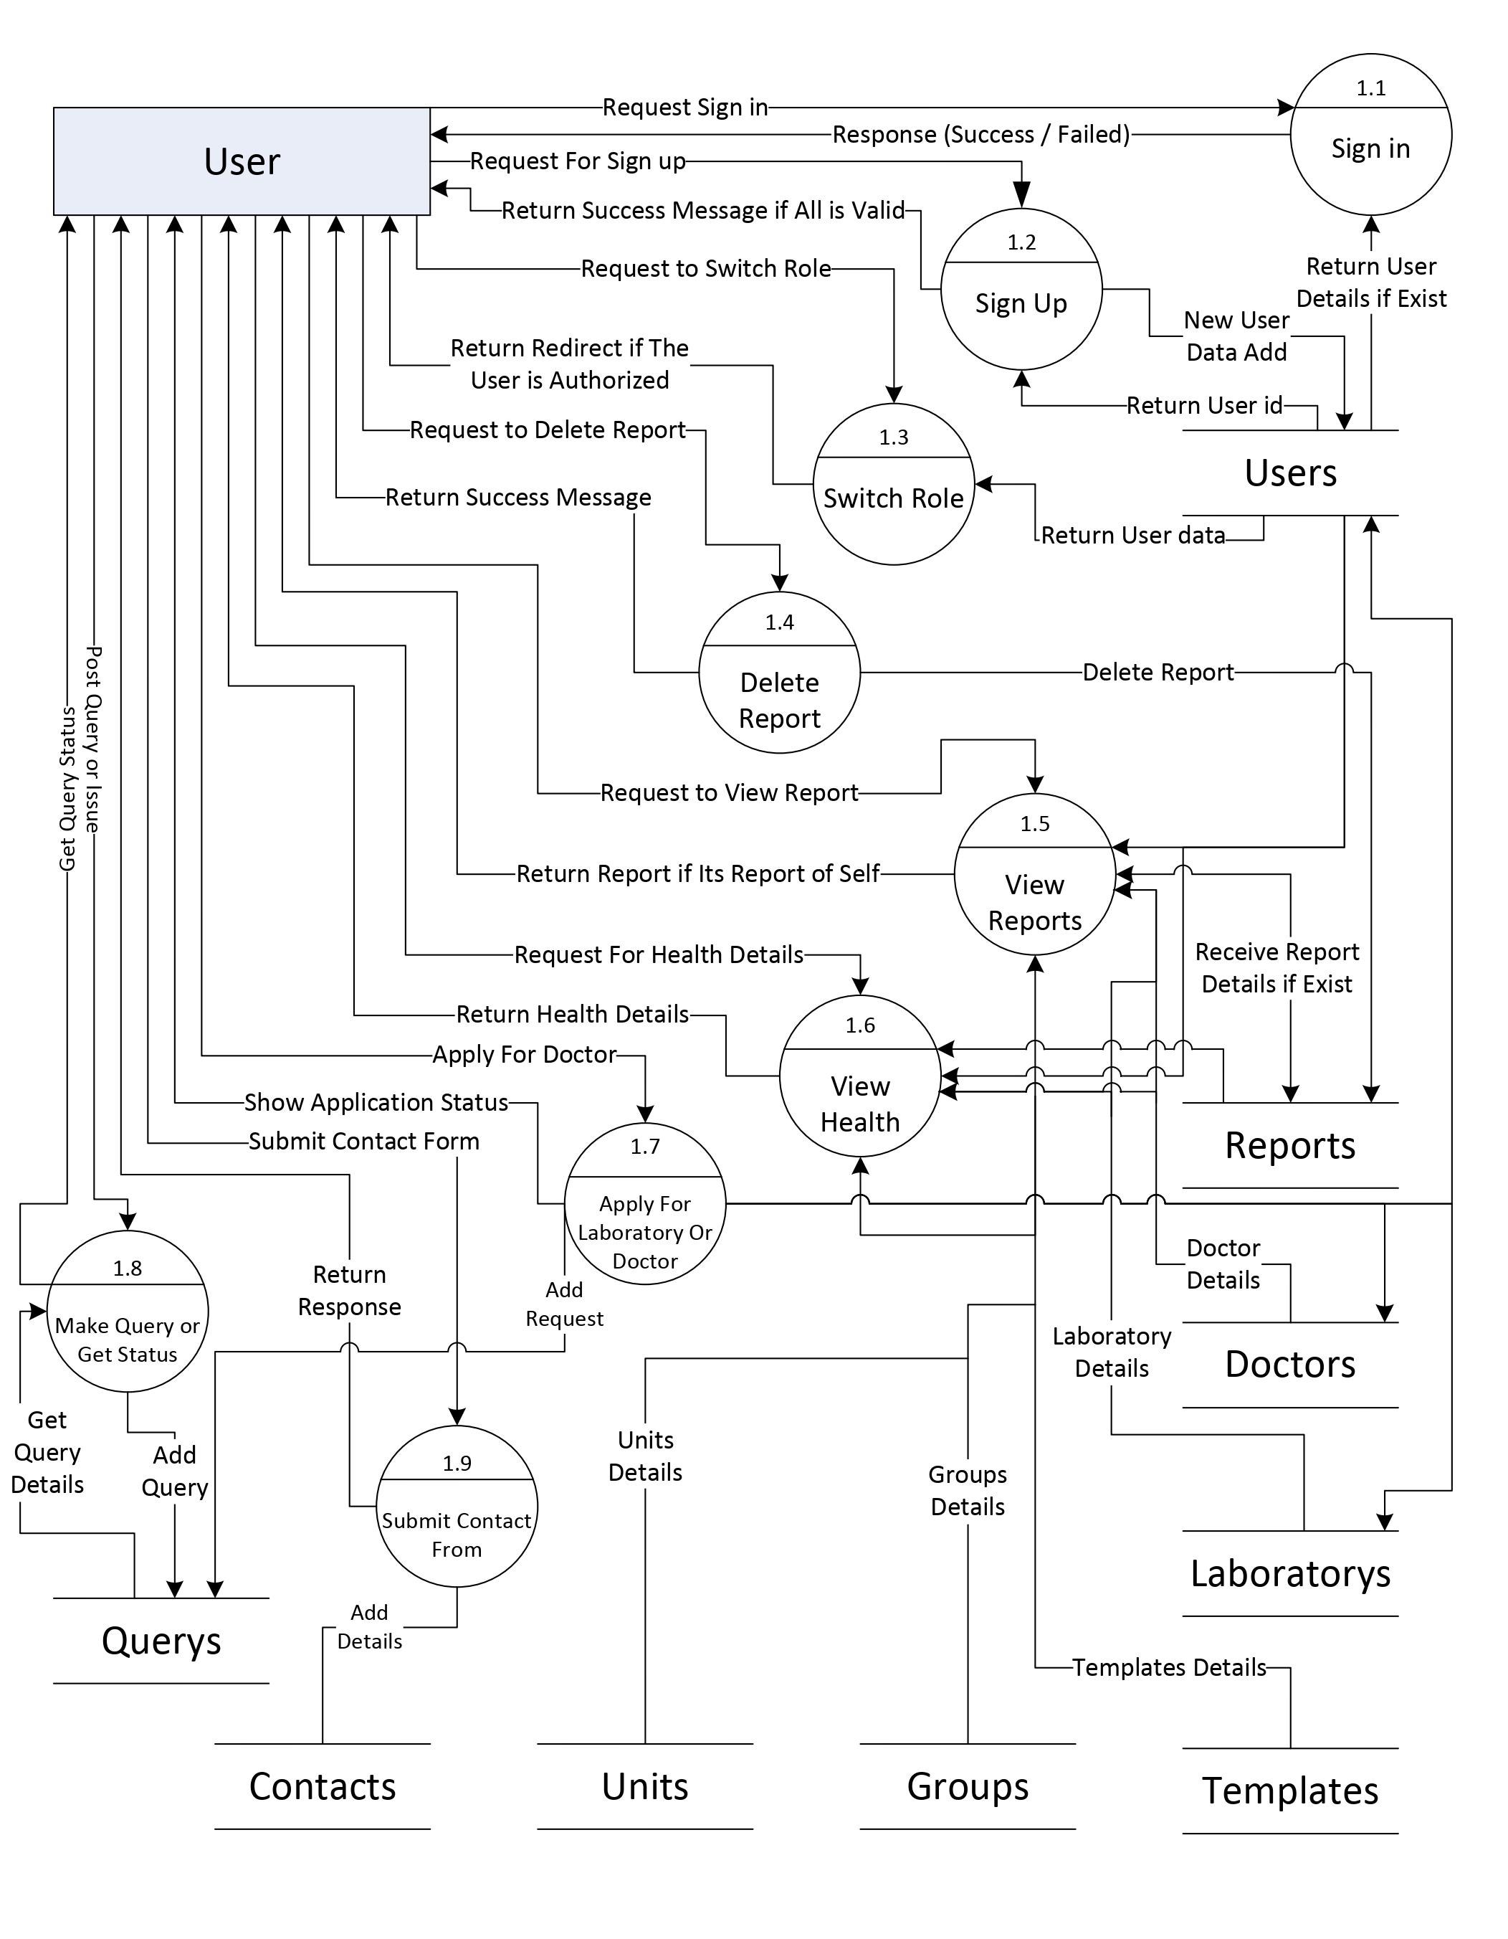

**1st Level Data Flow Diagram**

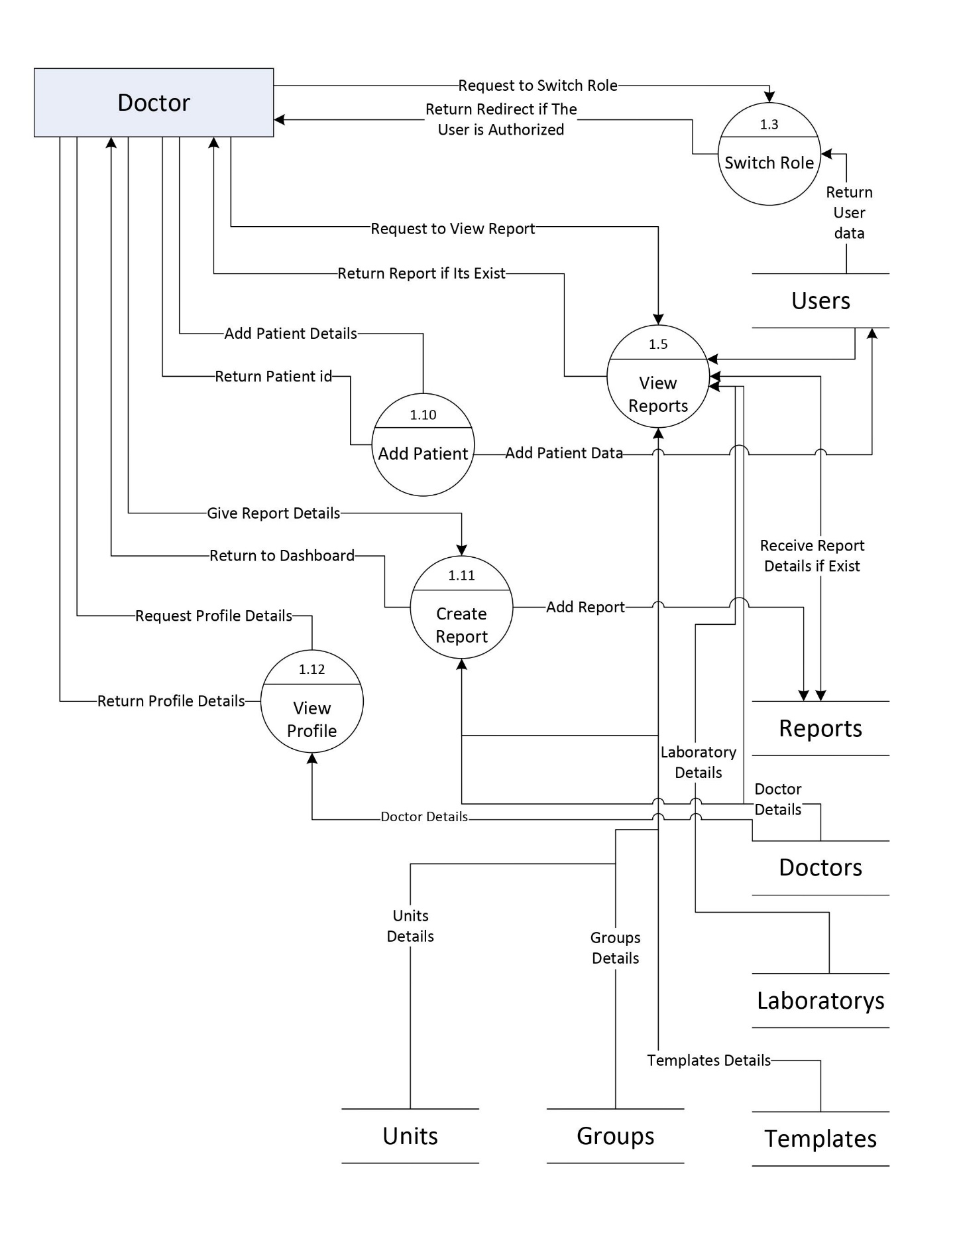

**1st Level Data Flow Diagram**

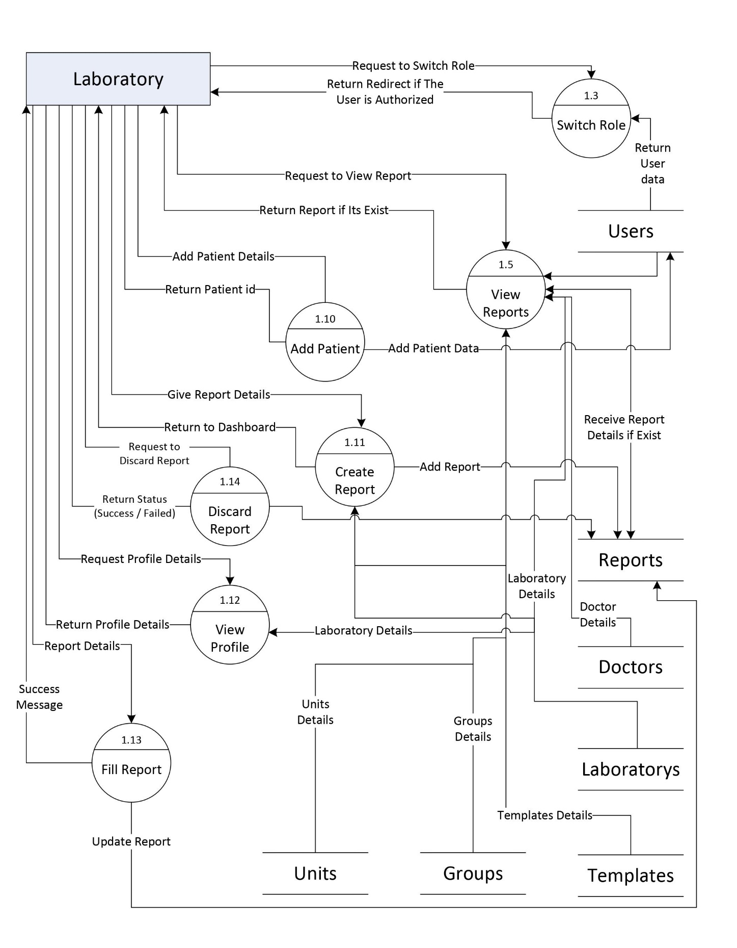

**1st Level Data Flow Diagram**

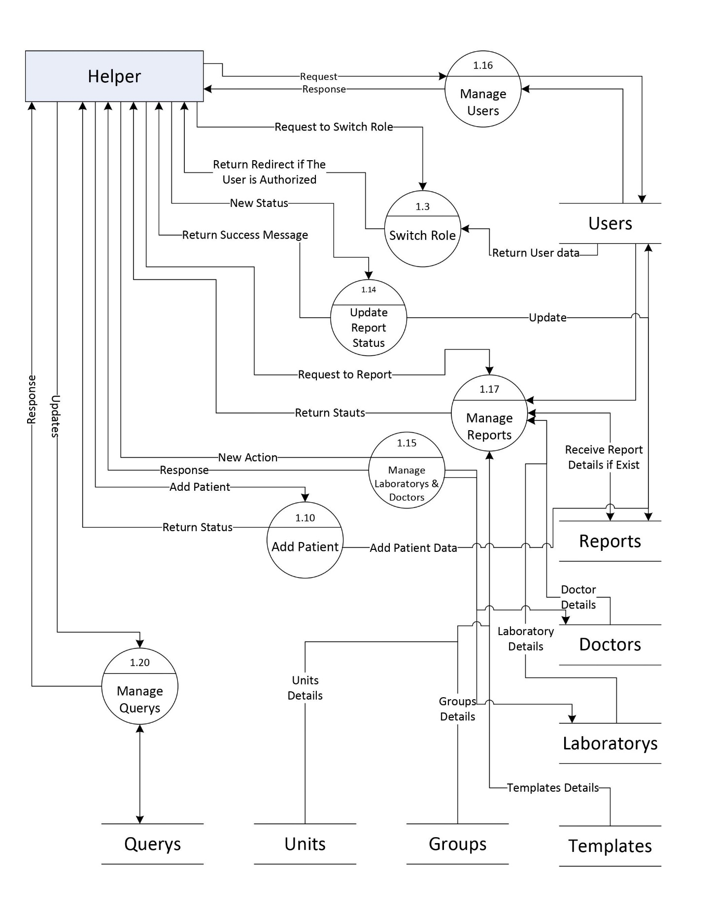

**Use Case Diagram**

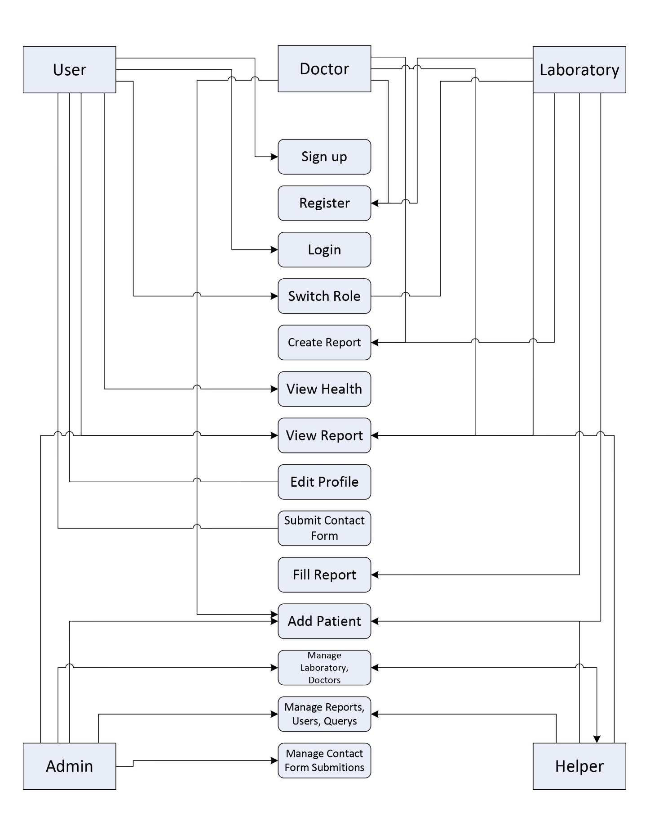

**E.R. Diagram**

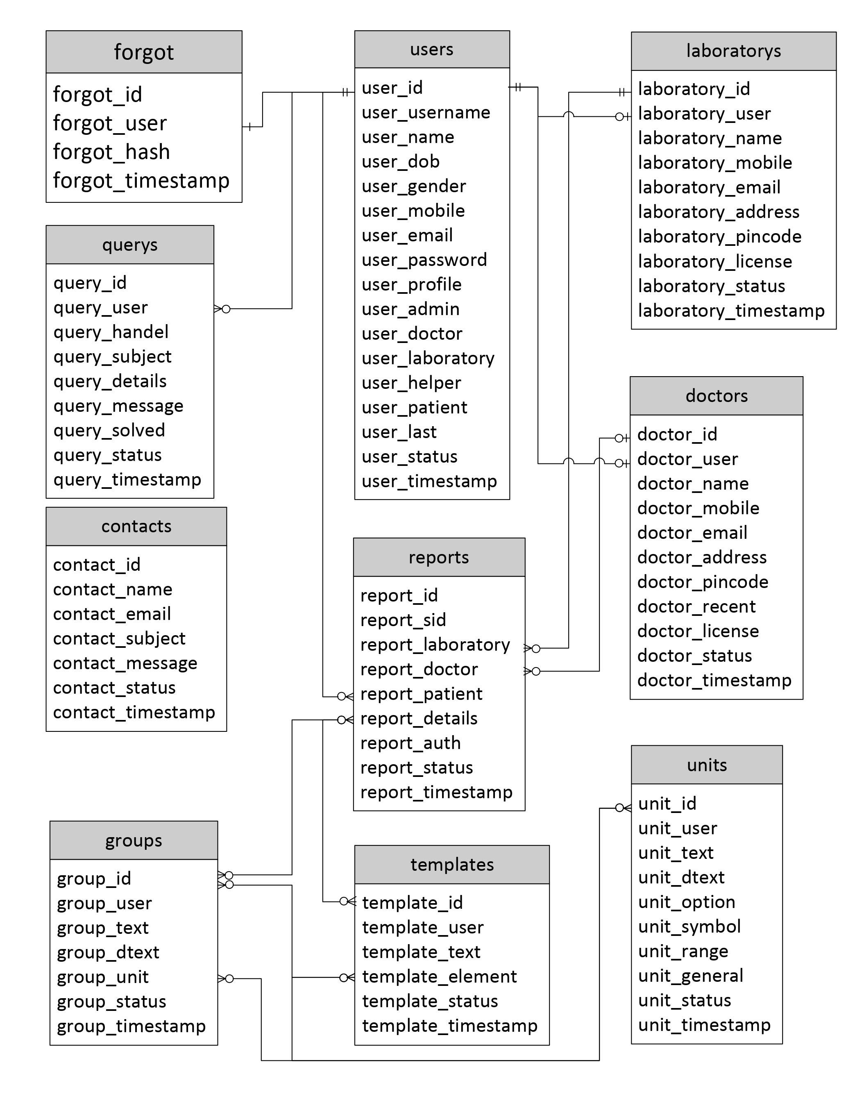

**Activity Diagram**

Admin

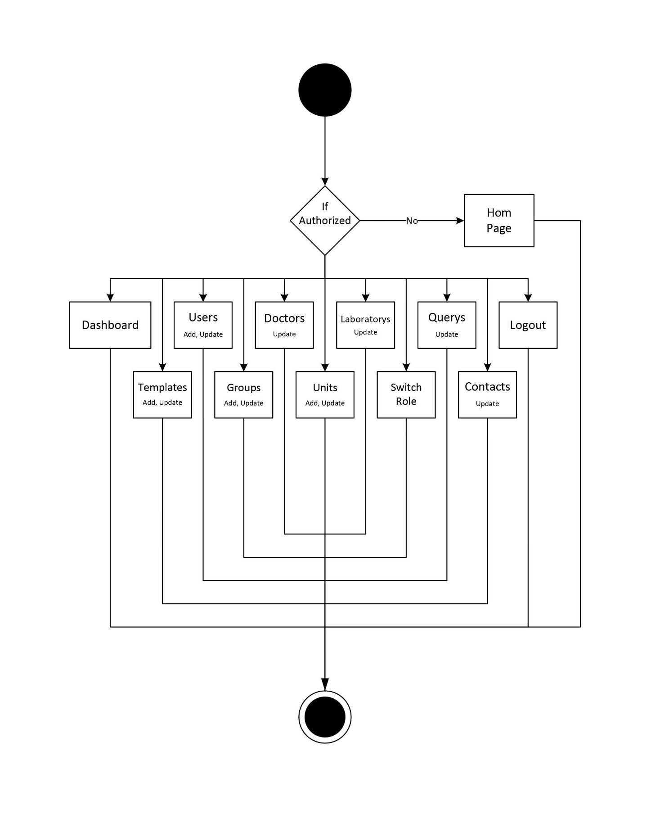

**Activity Diagram**

User

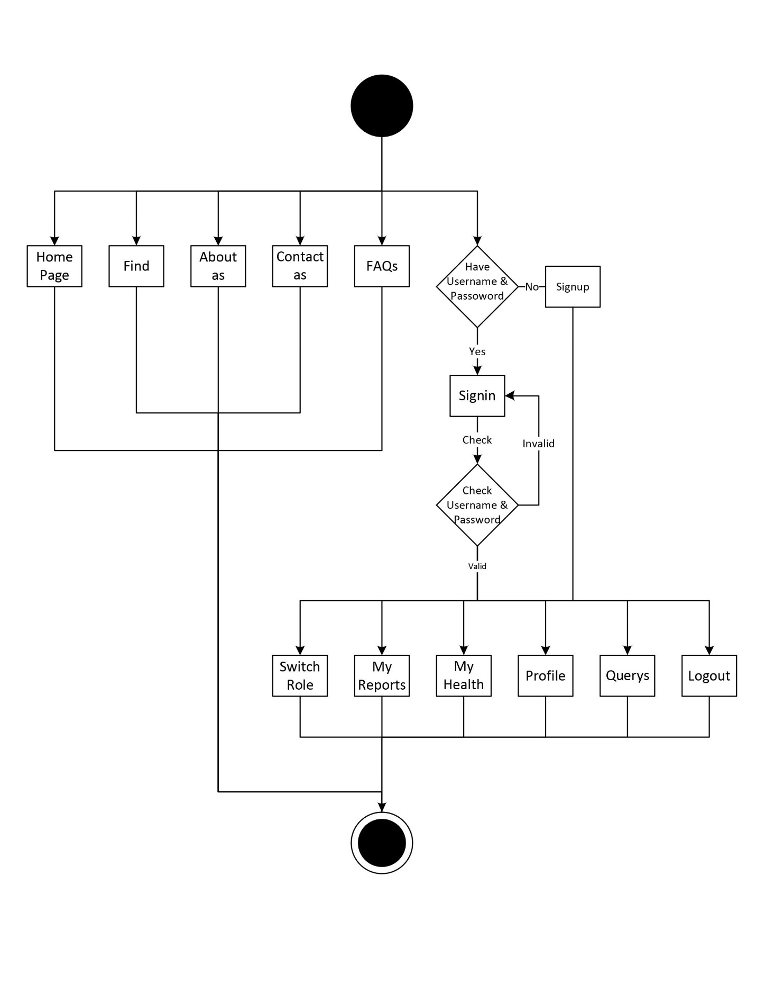

**Activity Diagram**

Doctor

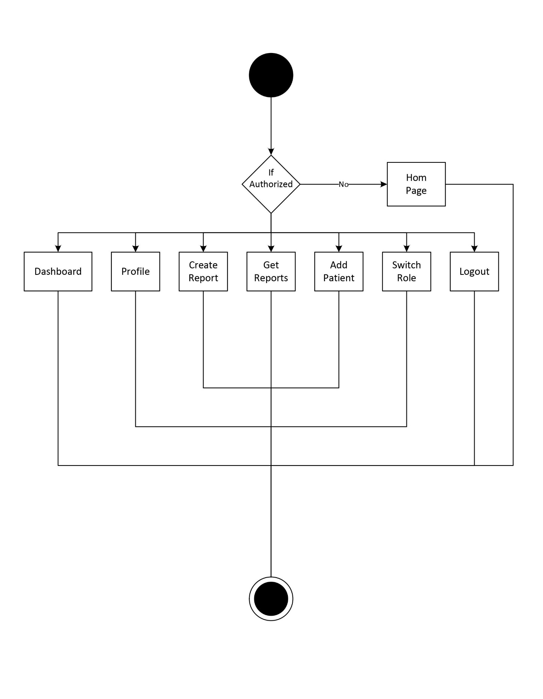

**Activity Diagram**

Laboratory

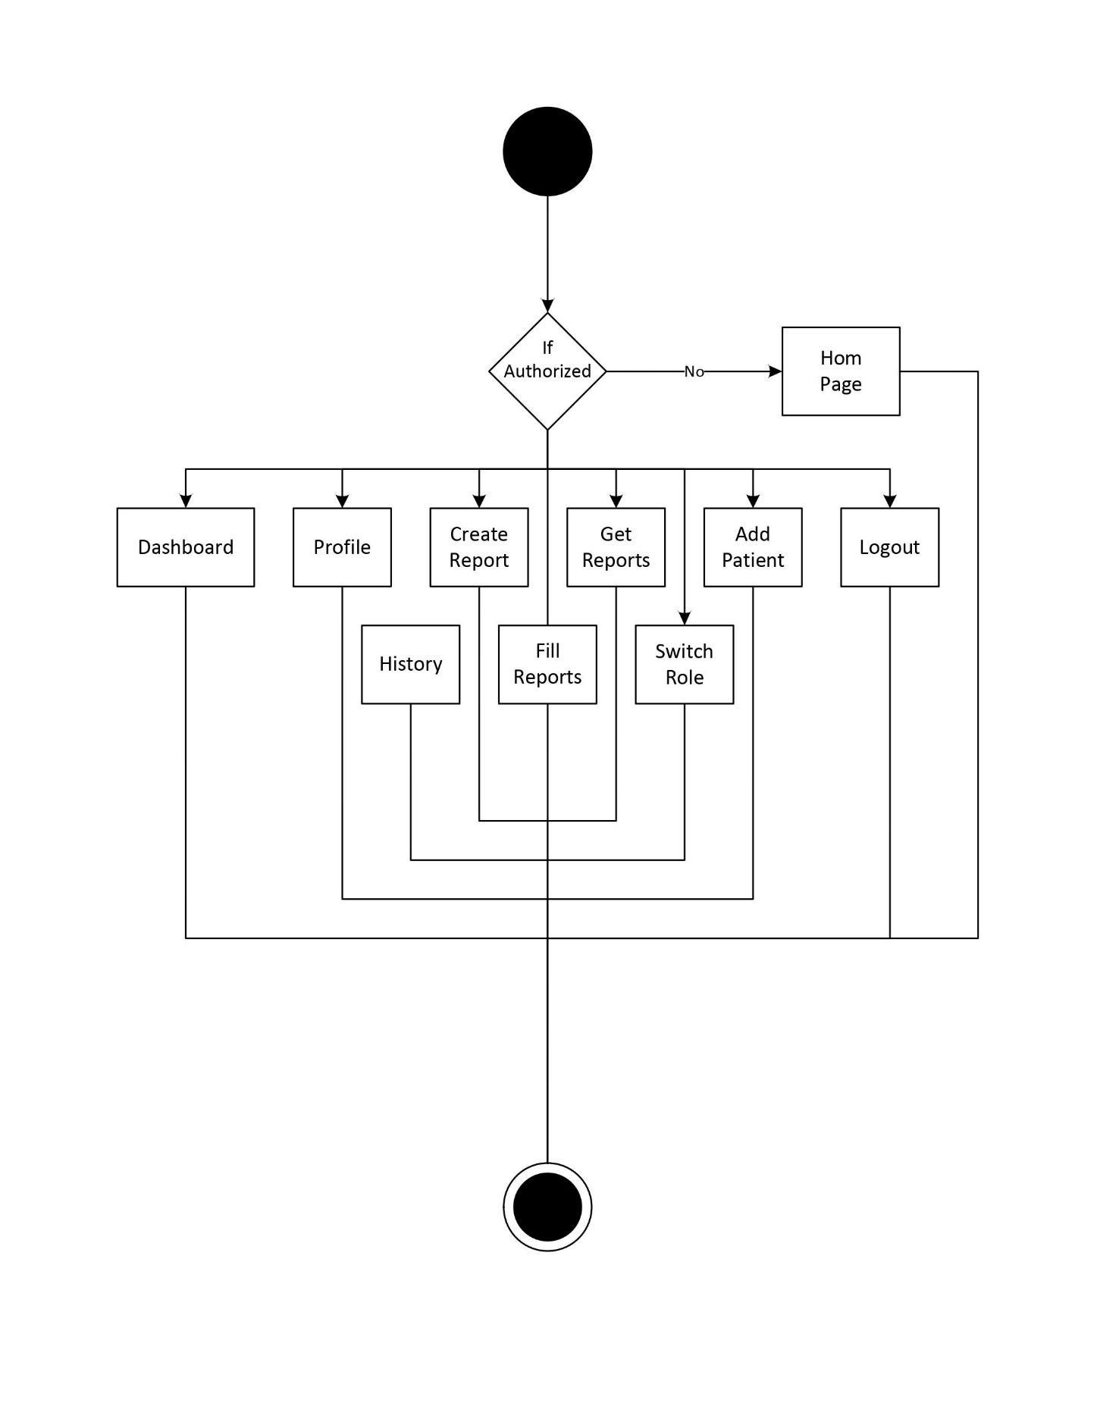

**Activity Diagram**

Helper

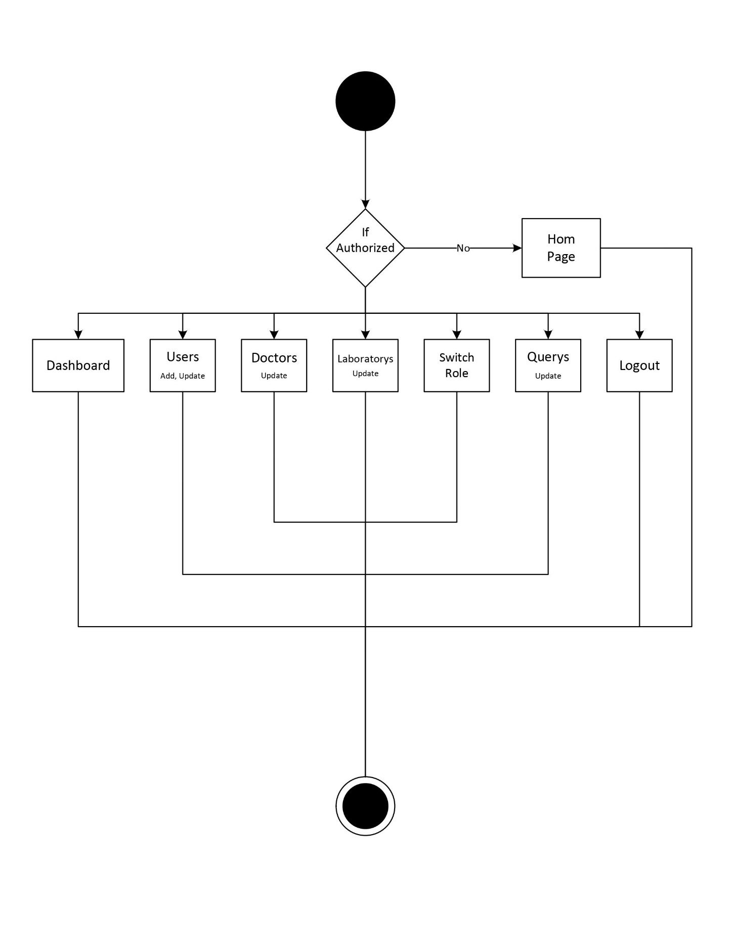

**Screenshots**

**Home Page**

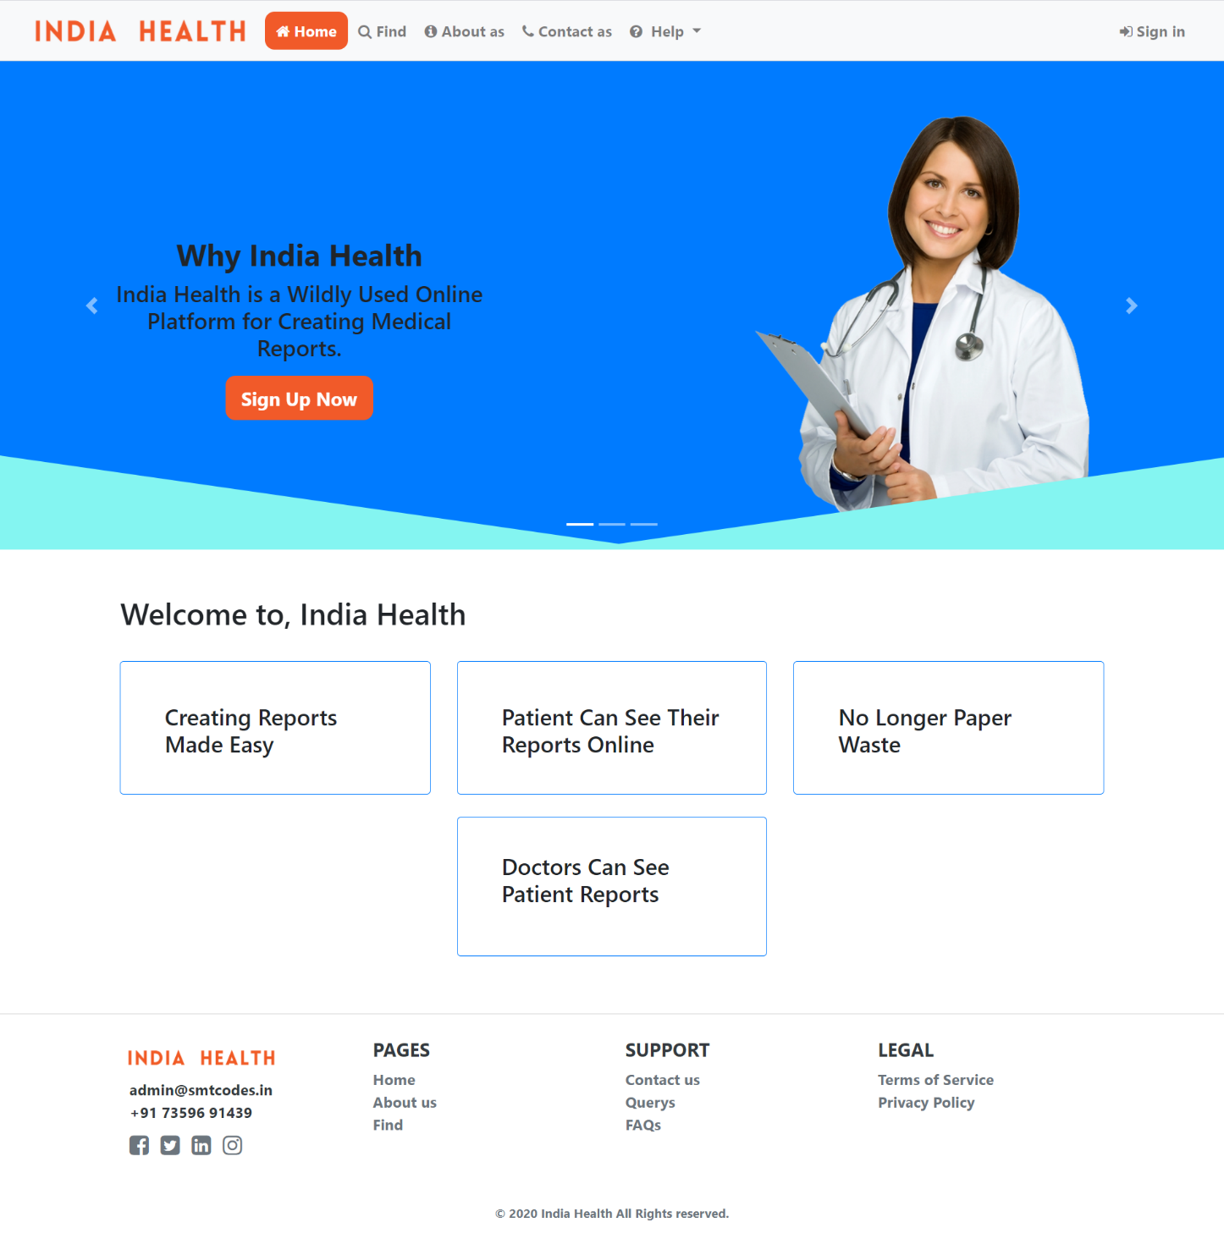

**Screenshots**

**Find**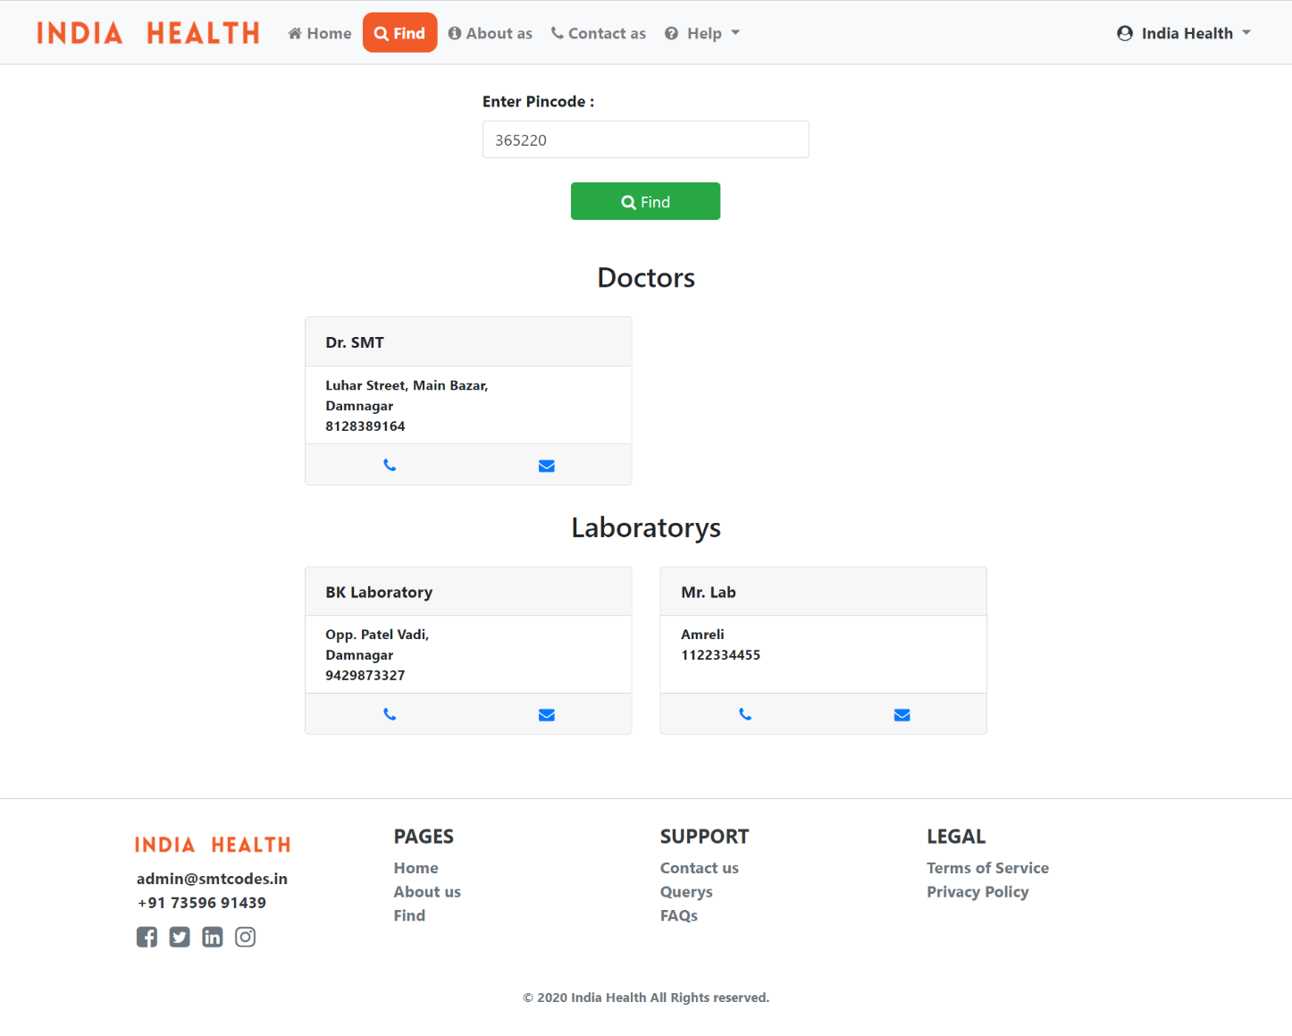

**Screenshots**

**Contact as**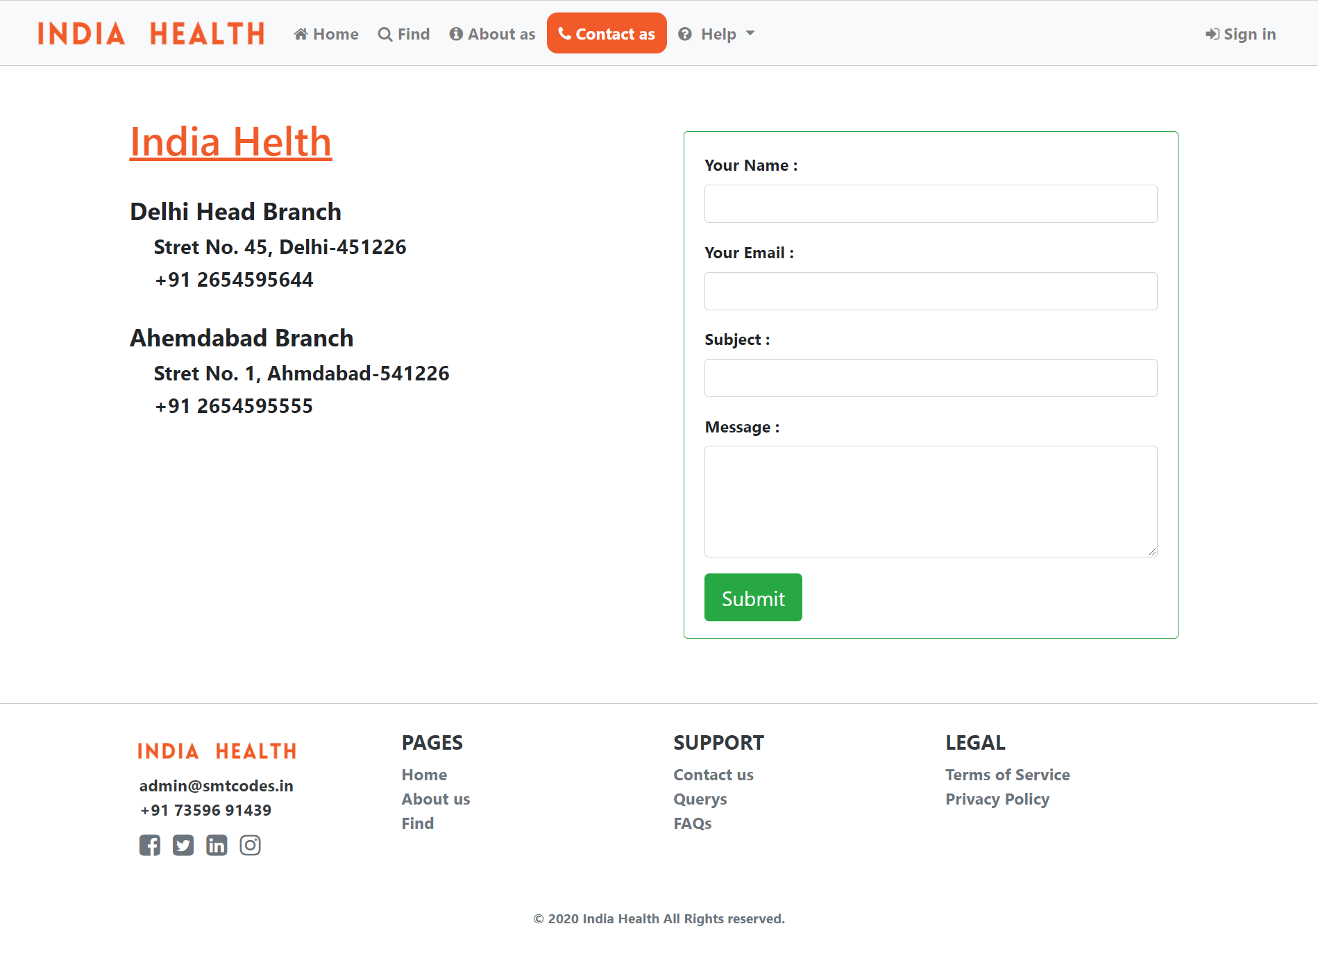

**Screenshots**

**Sign in / Sign up**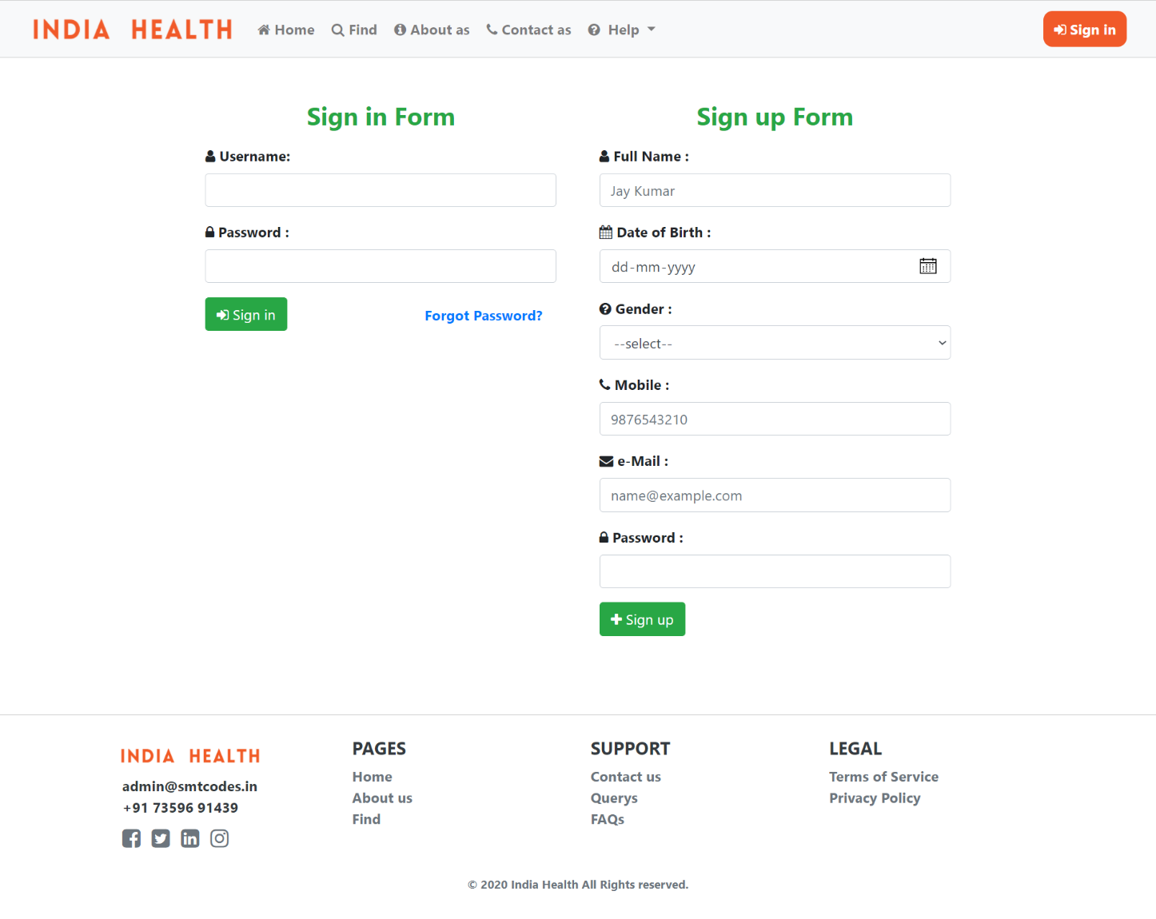

**Screenshots**

**Profile**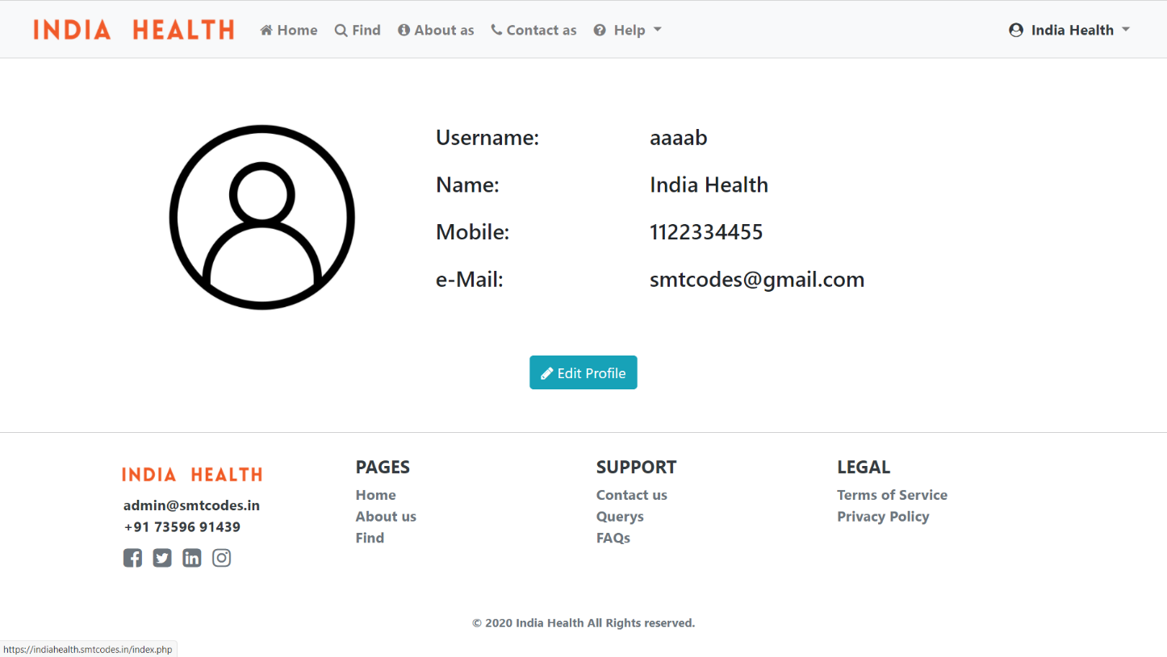

**Apply For Laboratory**

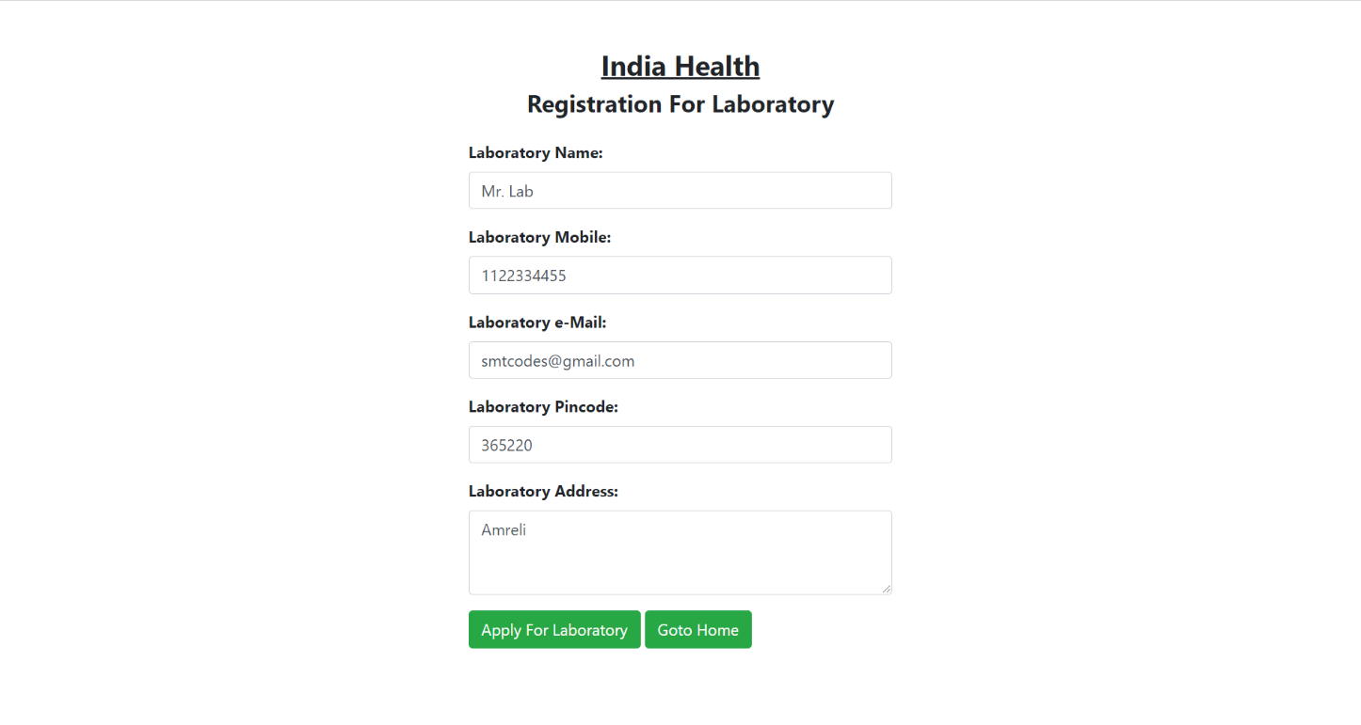

**Screenshots**

**My Reports**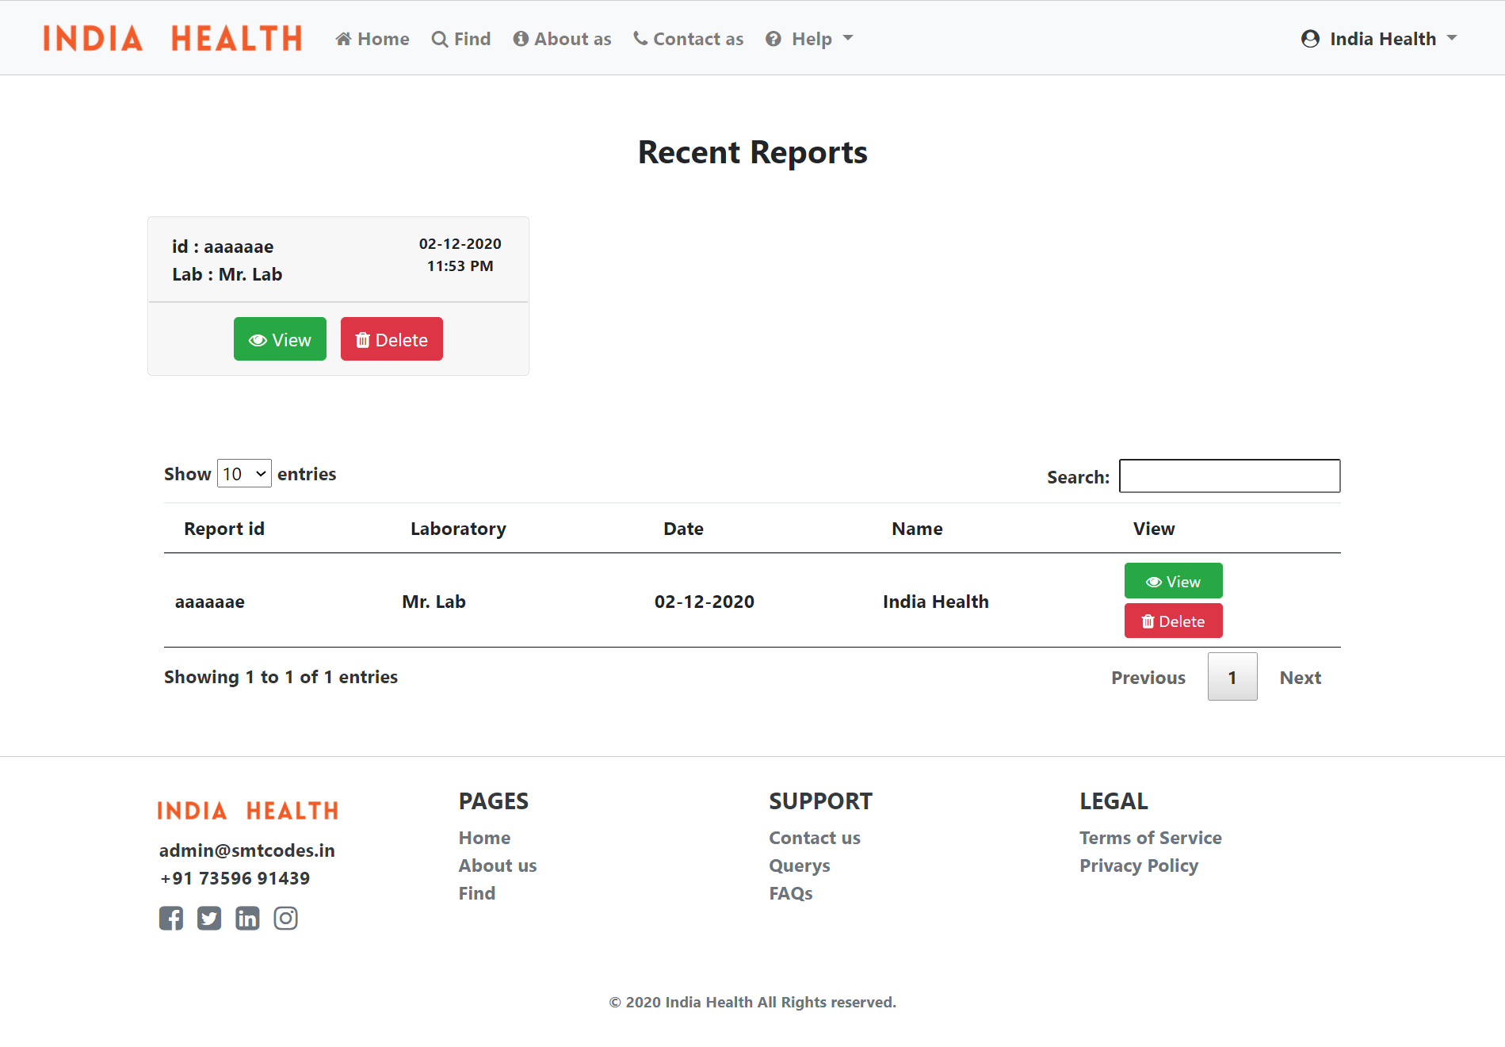

**Screenshots**

**My Health**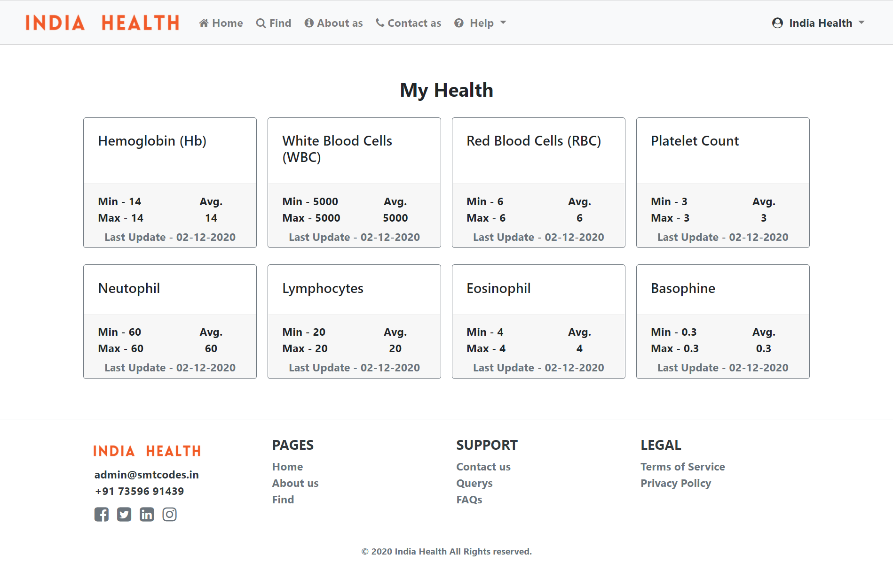

**Screenshots**

**Admin – Users**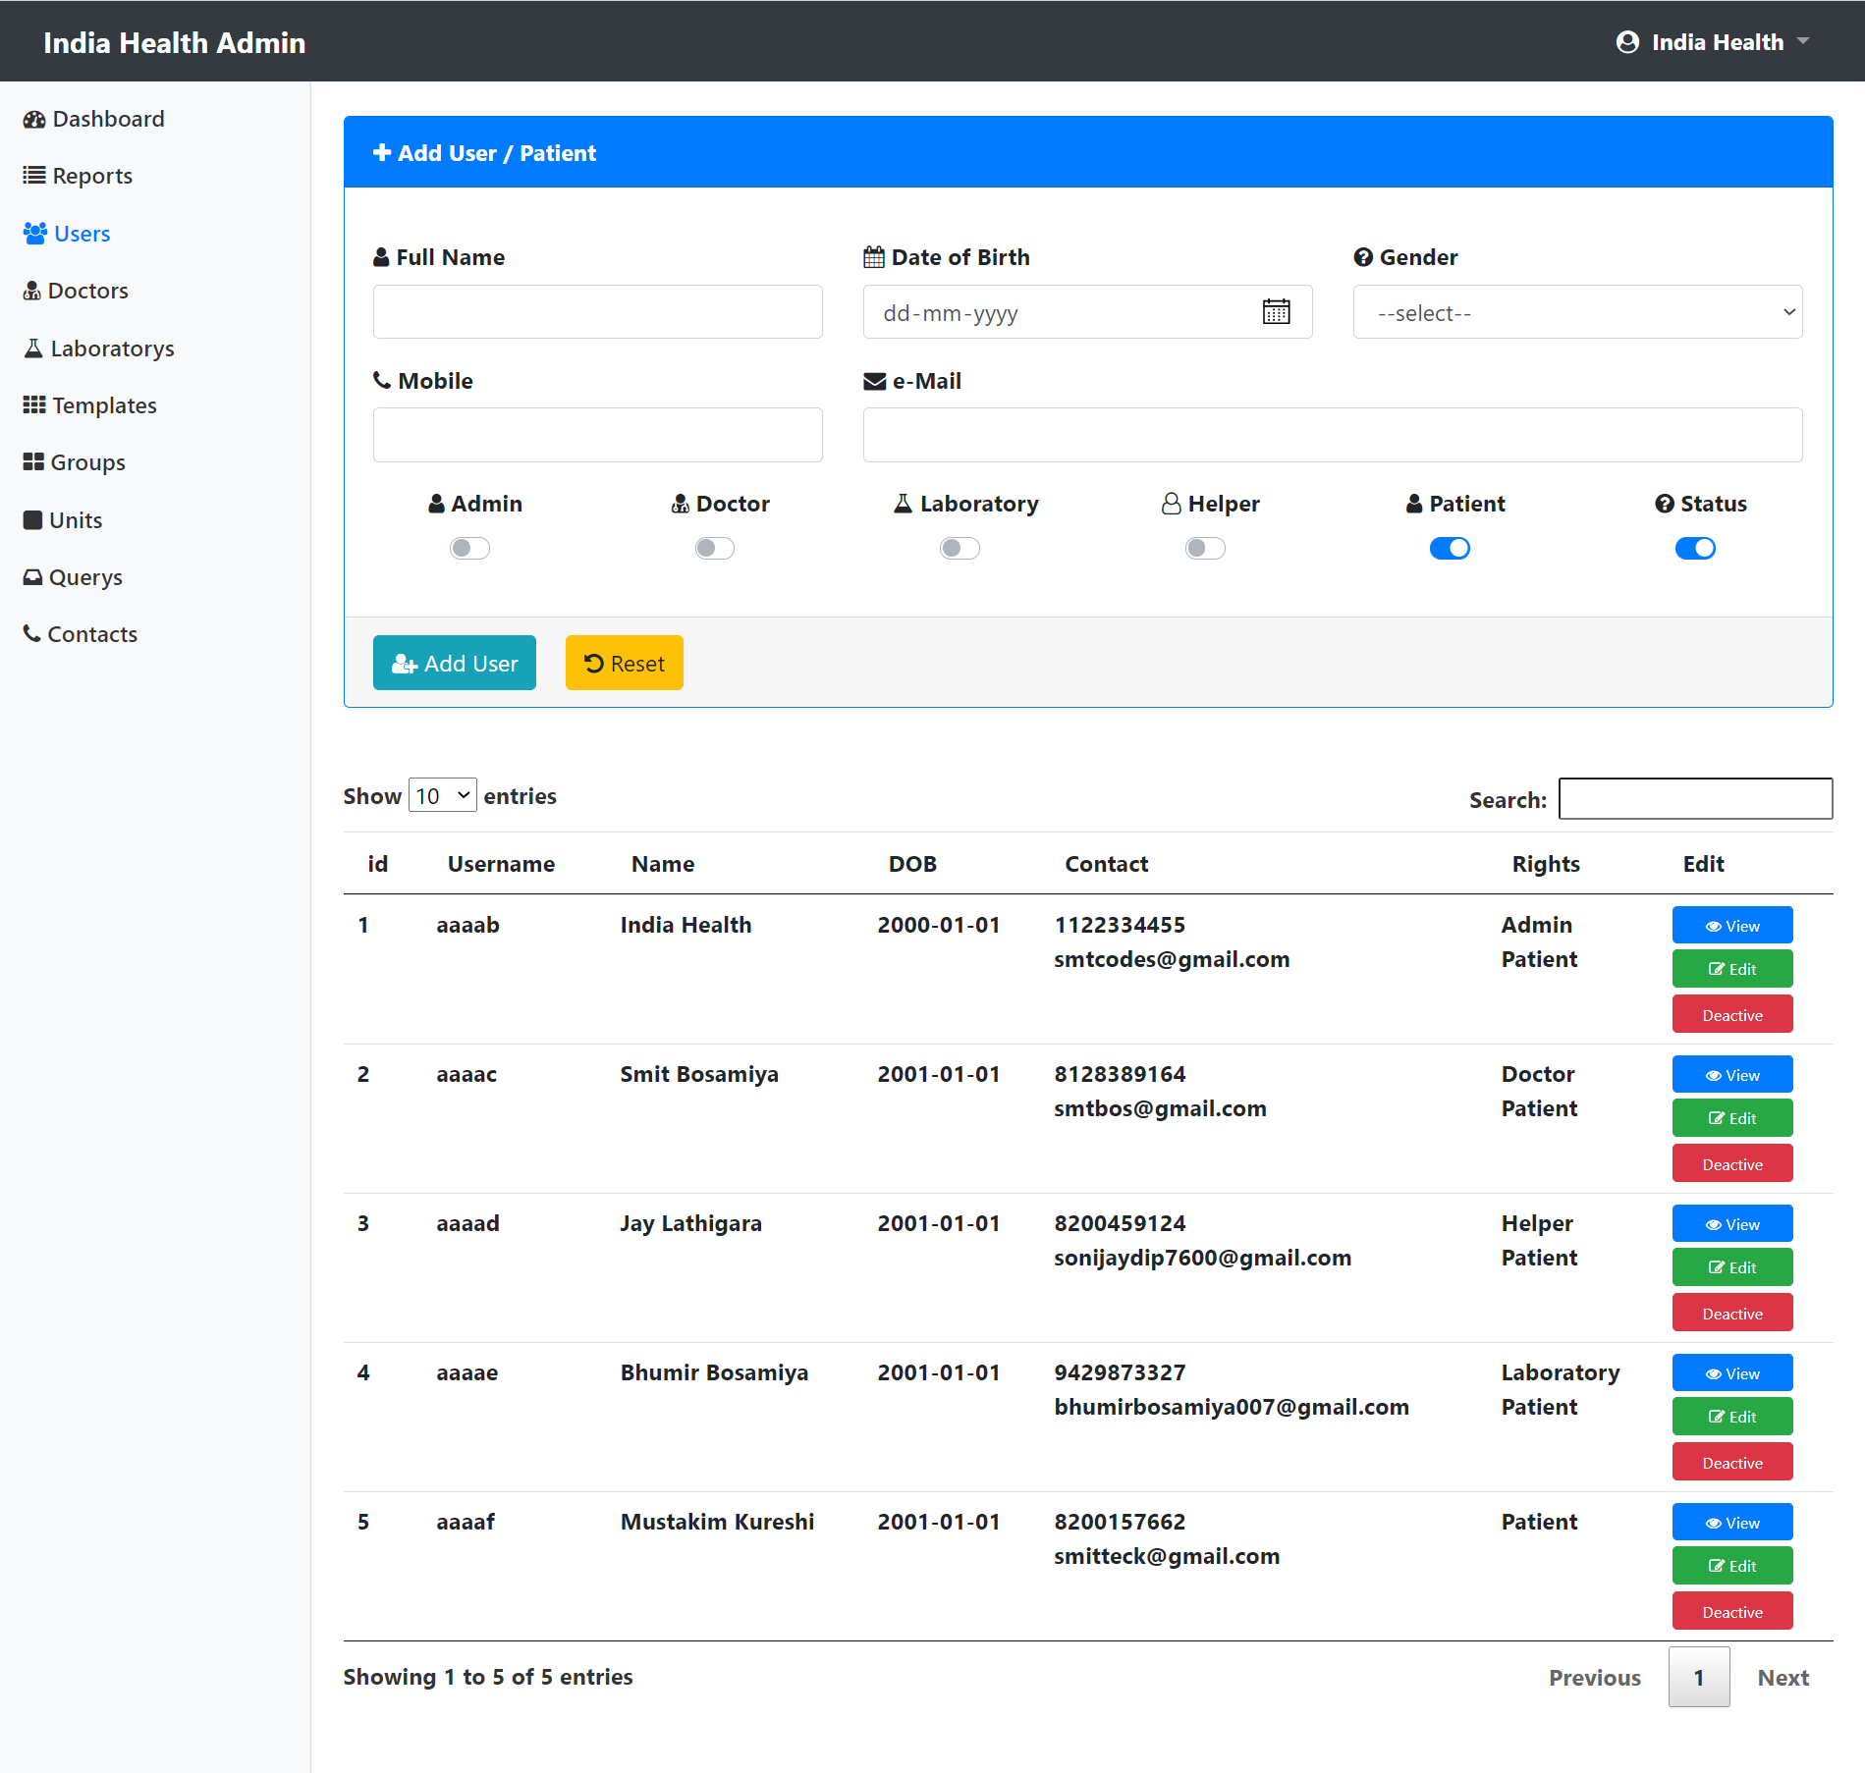

**Screenshots**

**Admin – User Edit**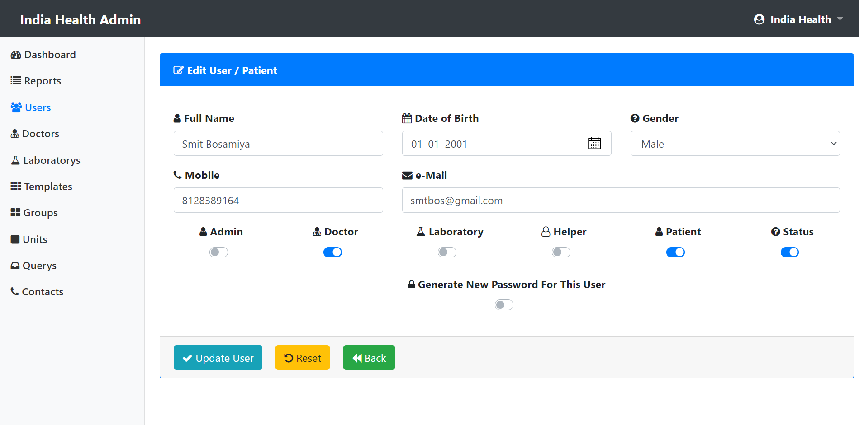

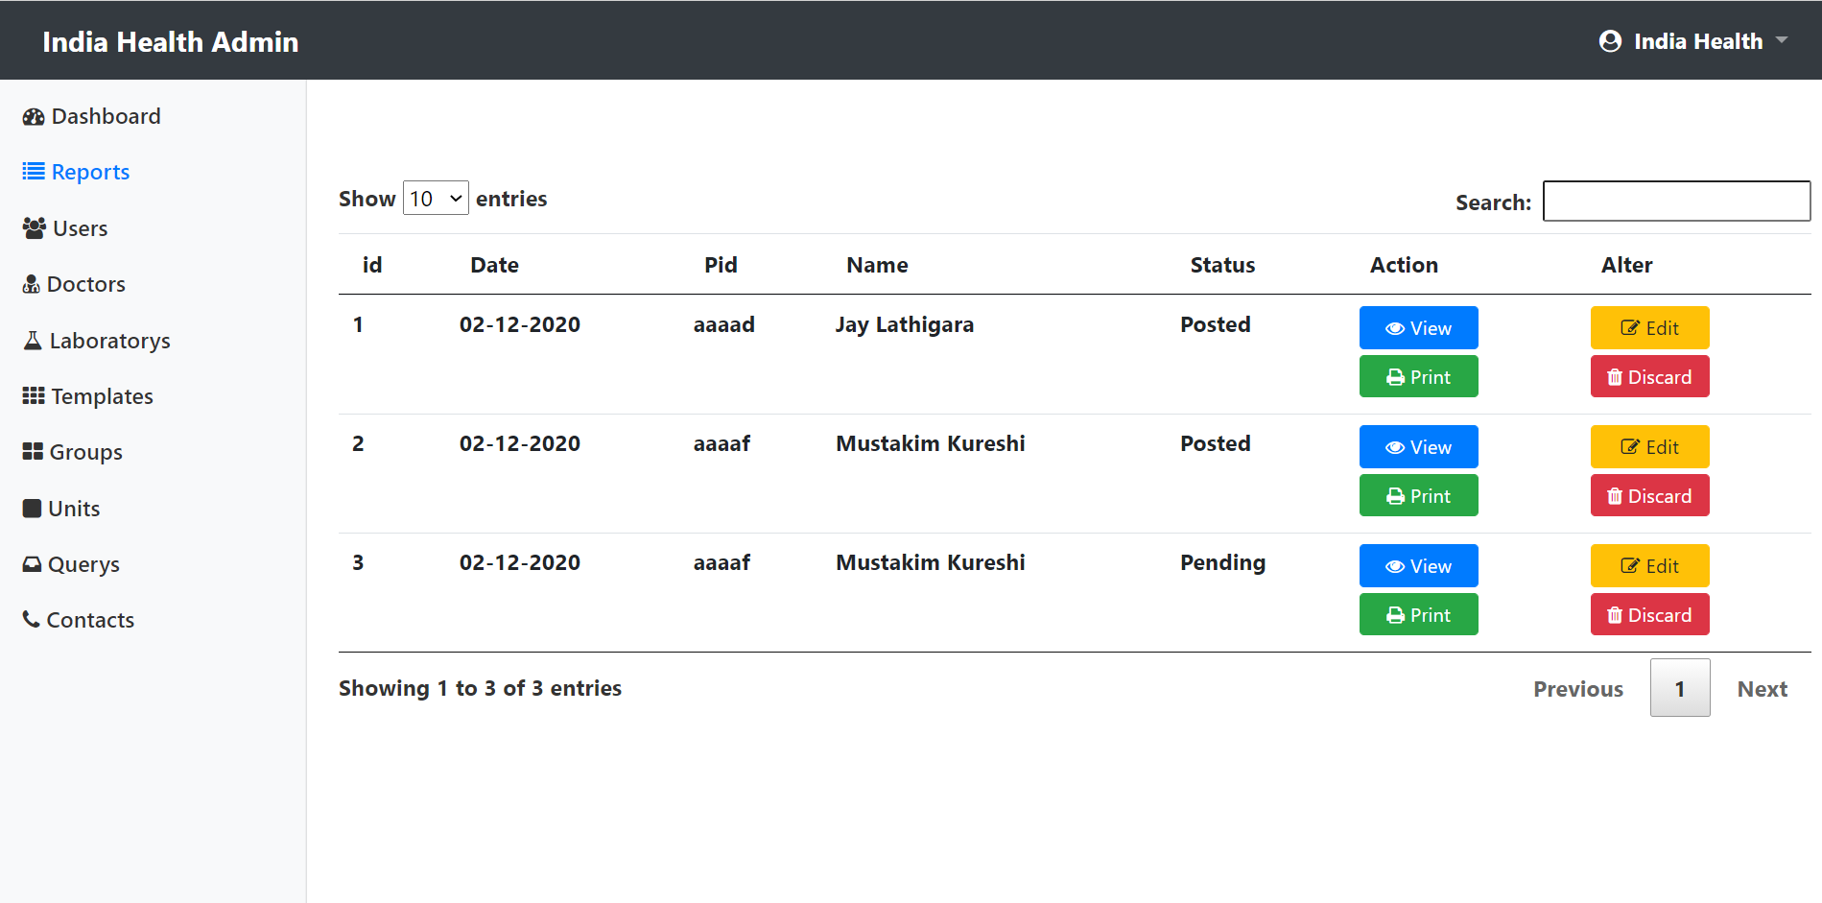**Admin –Reports**

**Screenshots**

**Admin – Reports View**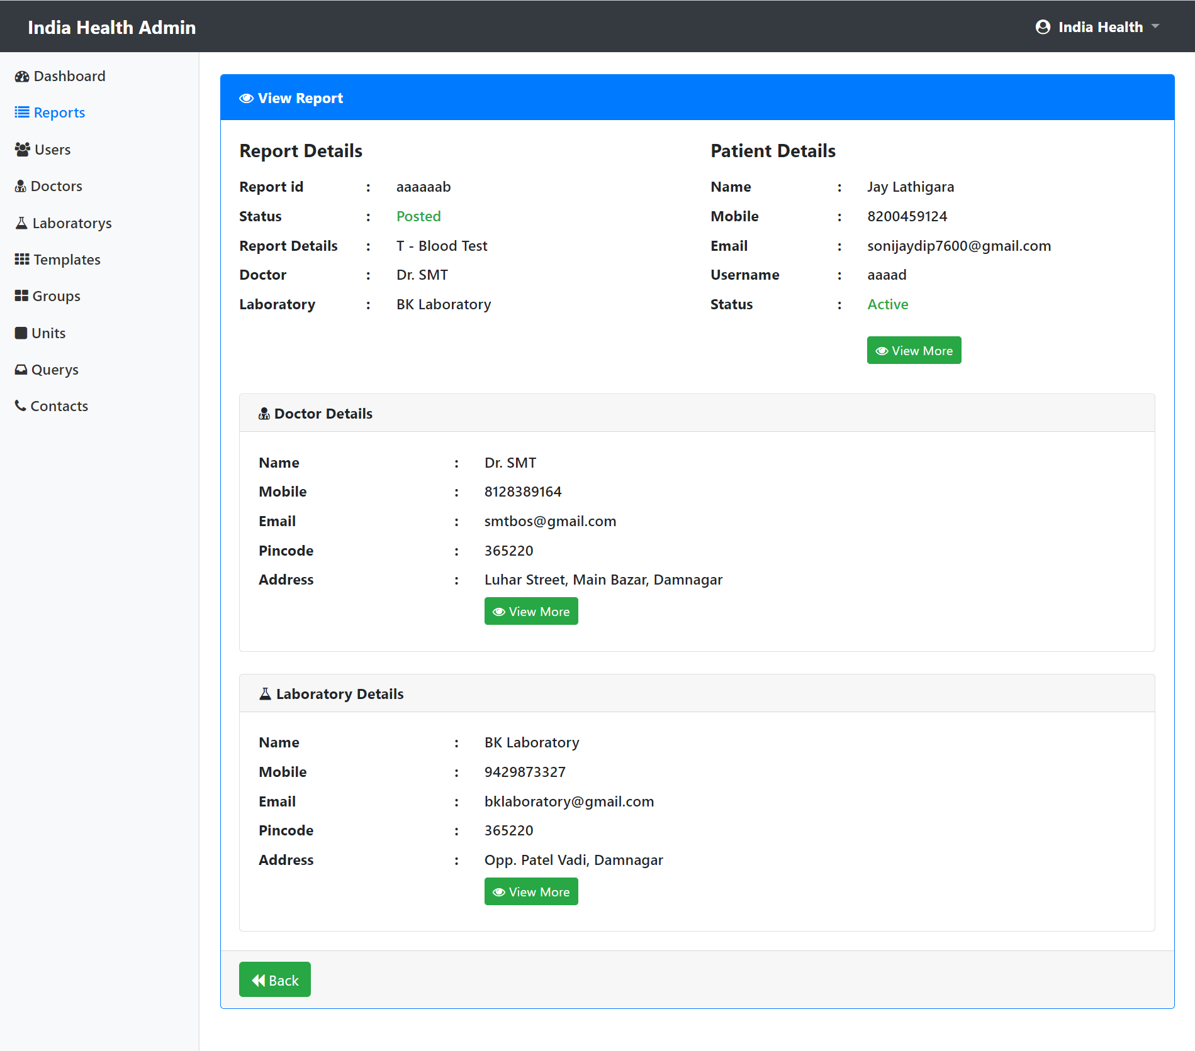

**Screenshots**

**Admin – Templates**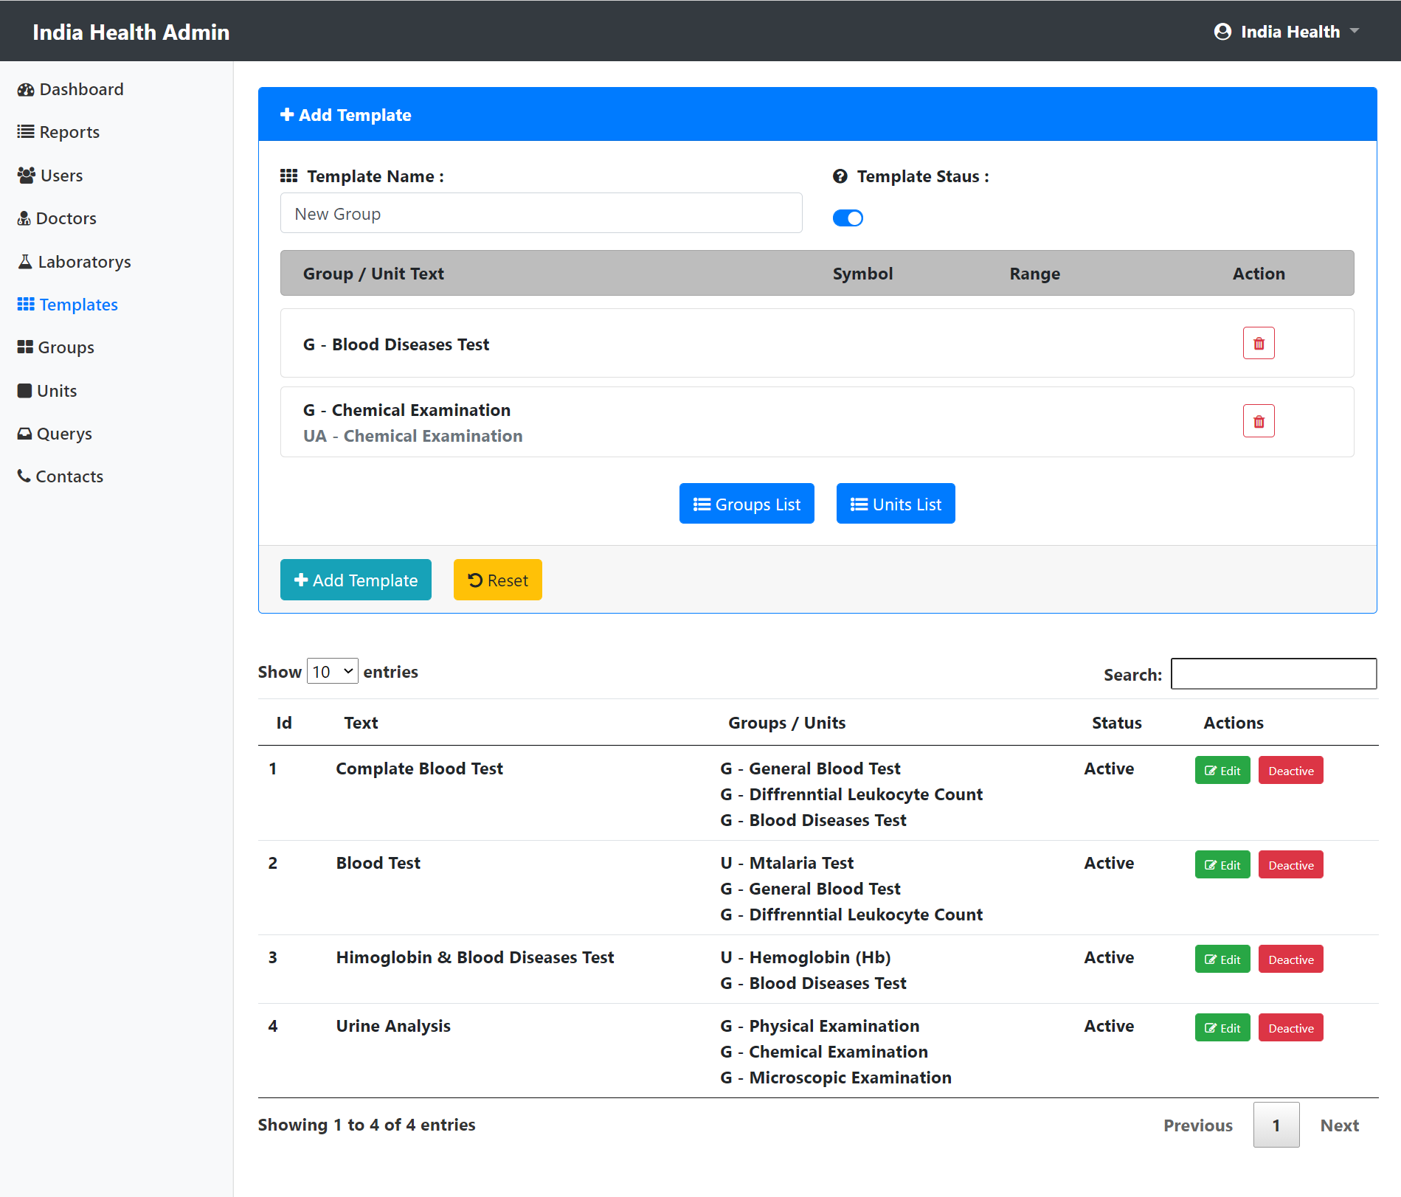

**Screenshots**

**Admin – Units**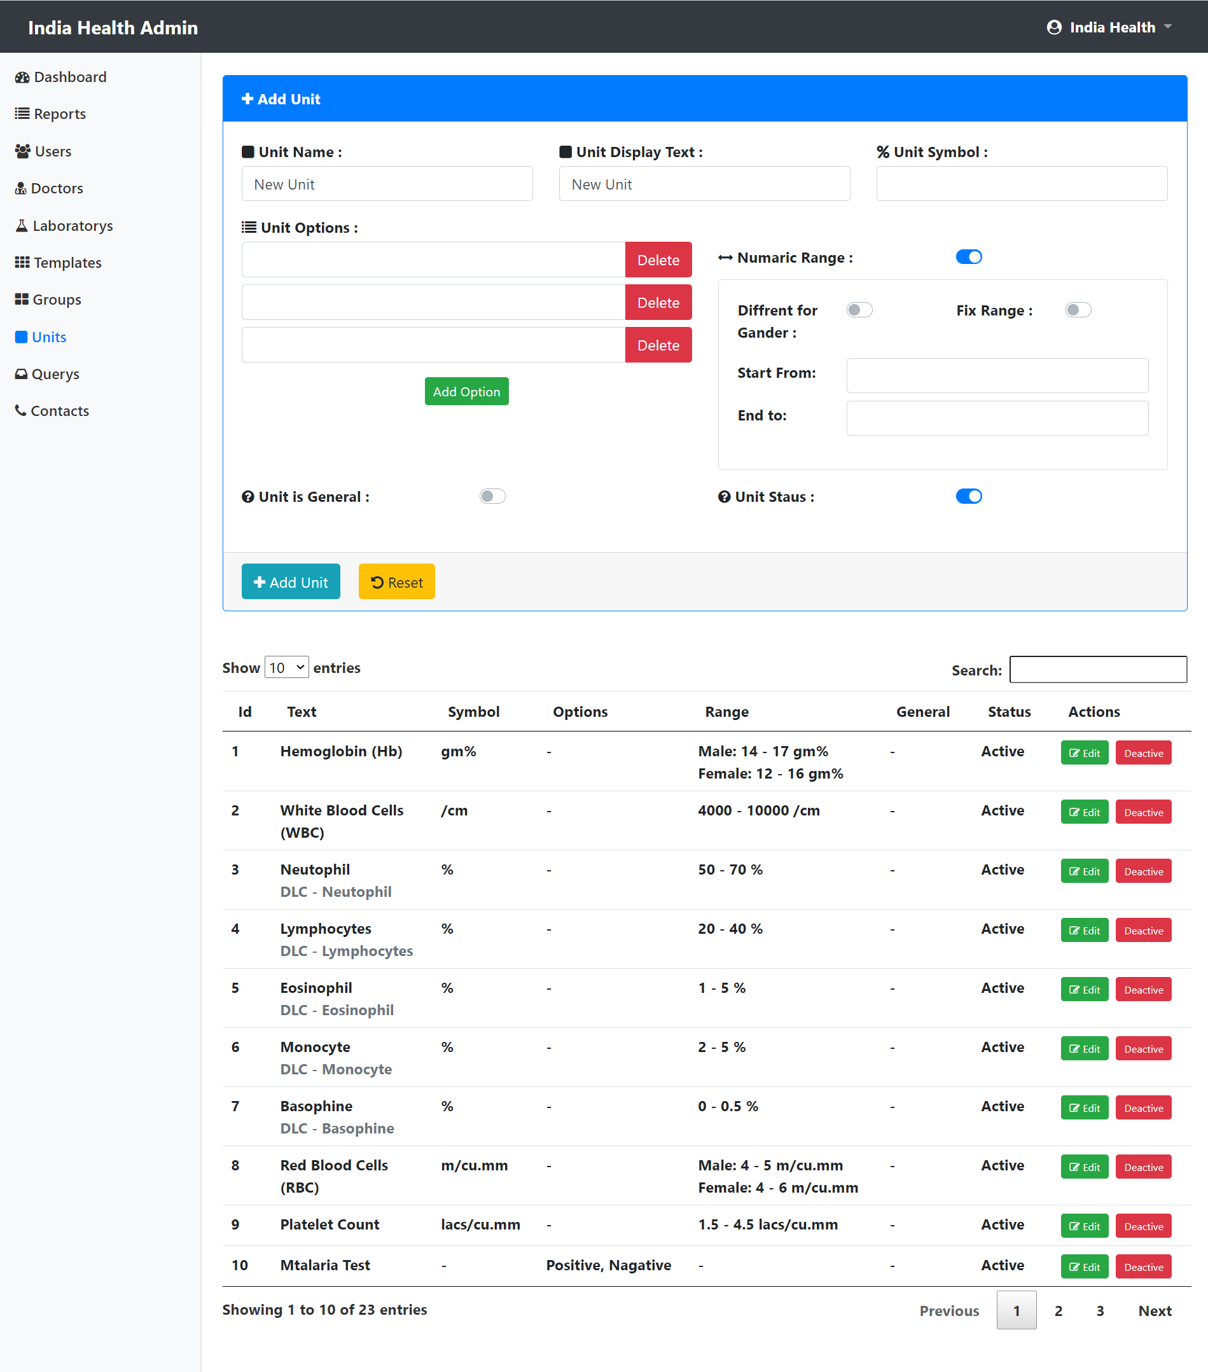

**Screenshots**

**Admin – Doctors**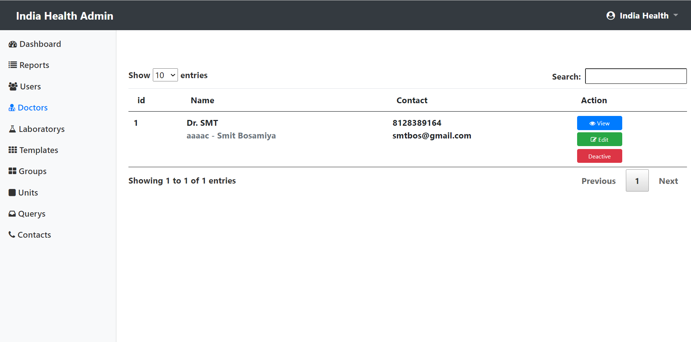

**Admin – Laboratorys**

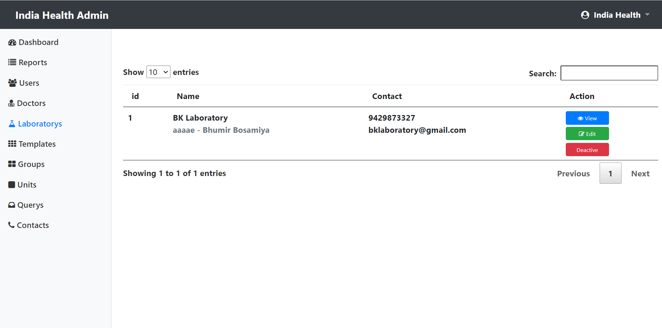

**Screenshots**

**Admin – Querys**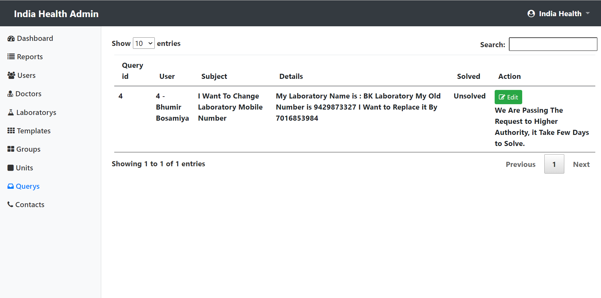

**Admin – Contacts**

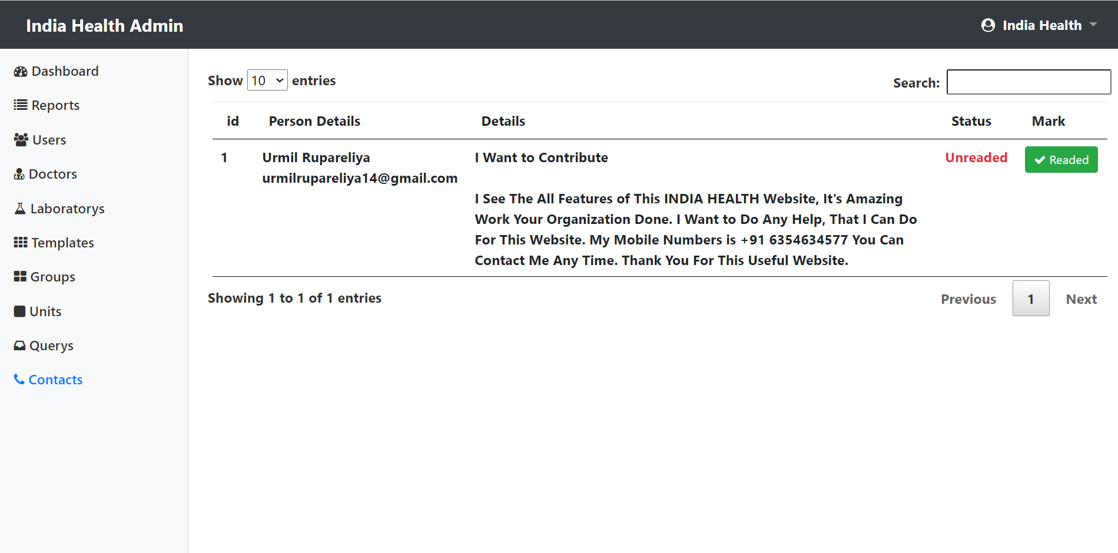

**Screenshots**

**Doctor – Dashboard**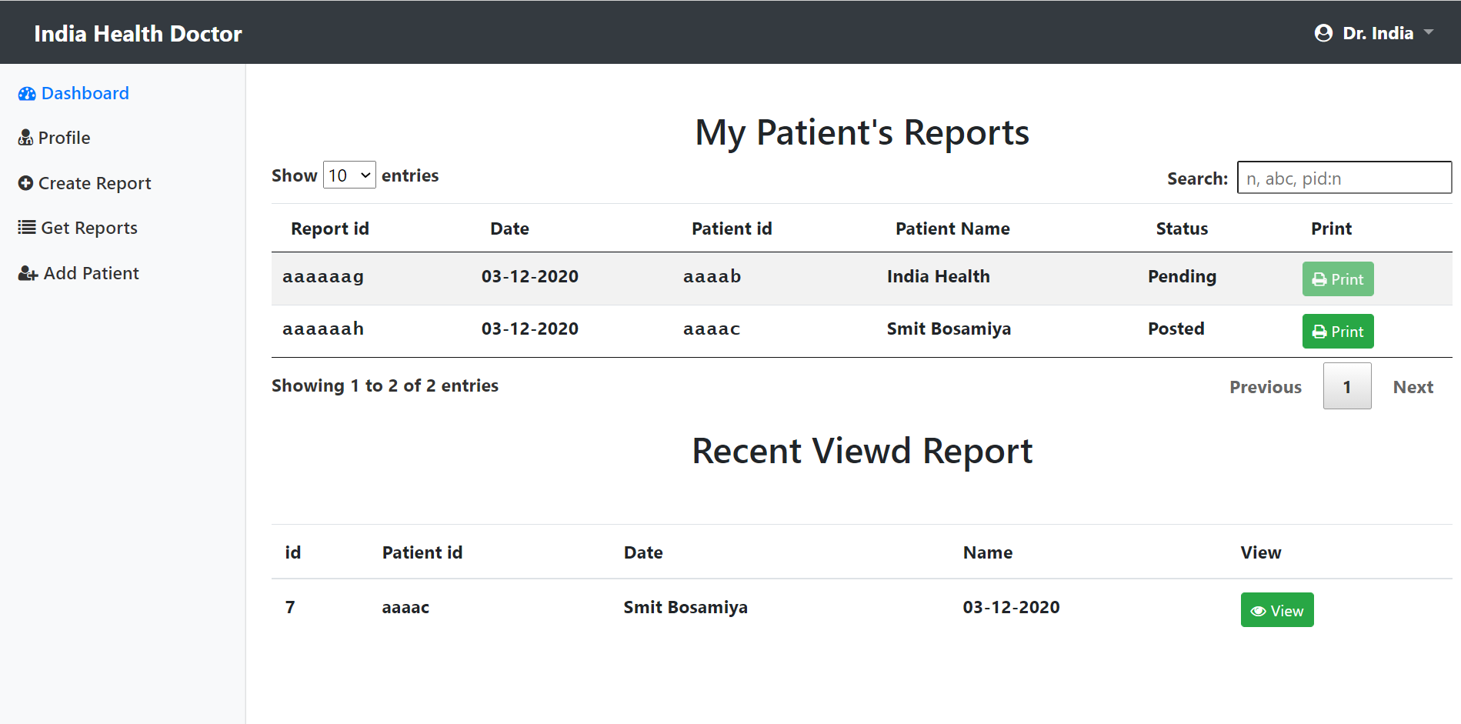

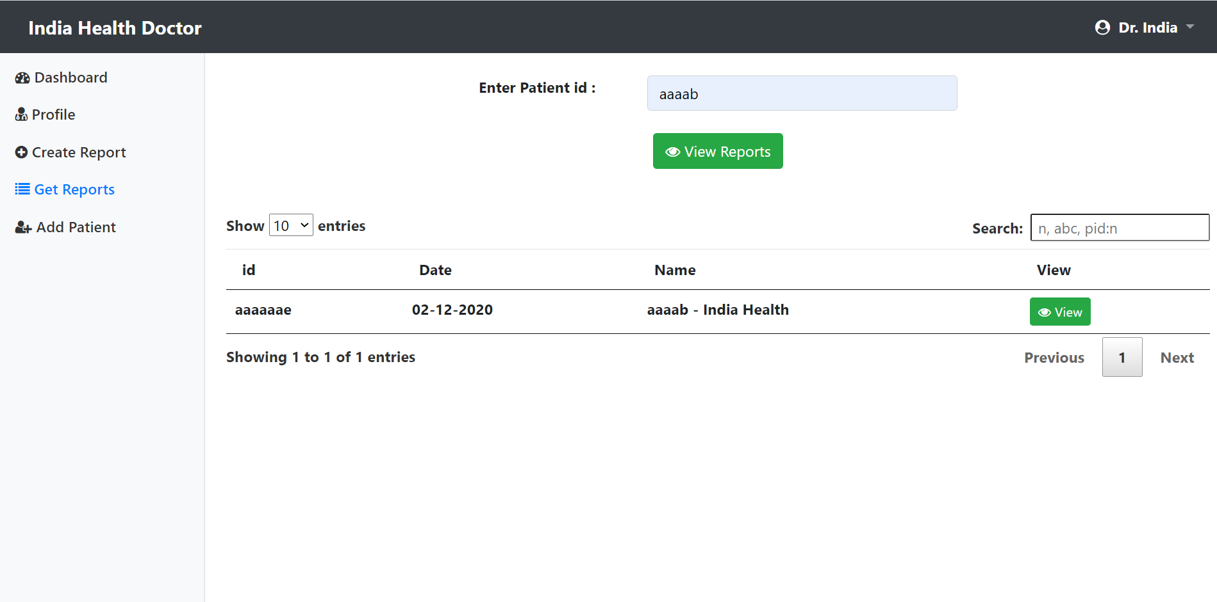**Doctor – Dashboard**

**Screenshots**

**Laboratory – Create Report**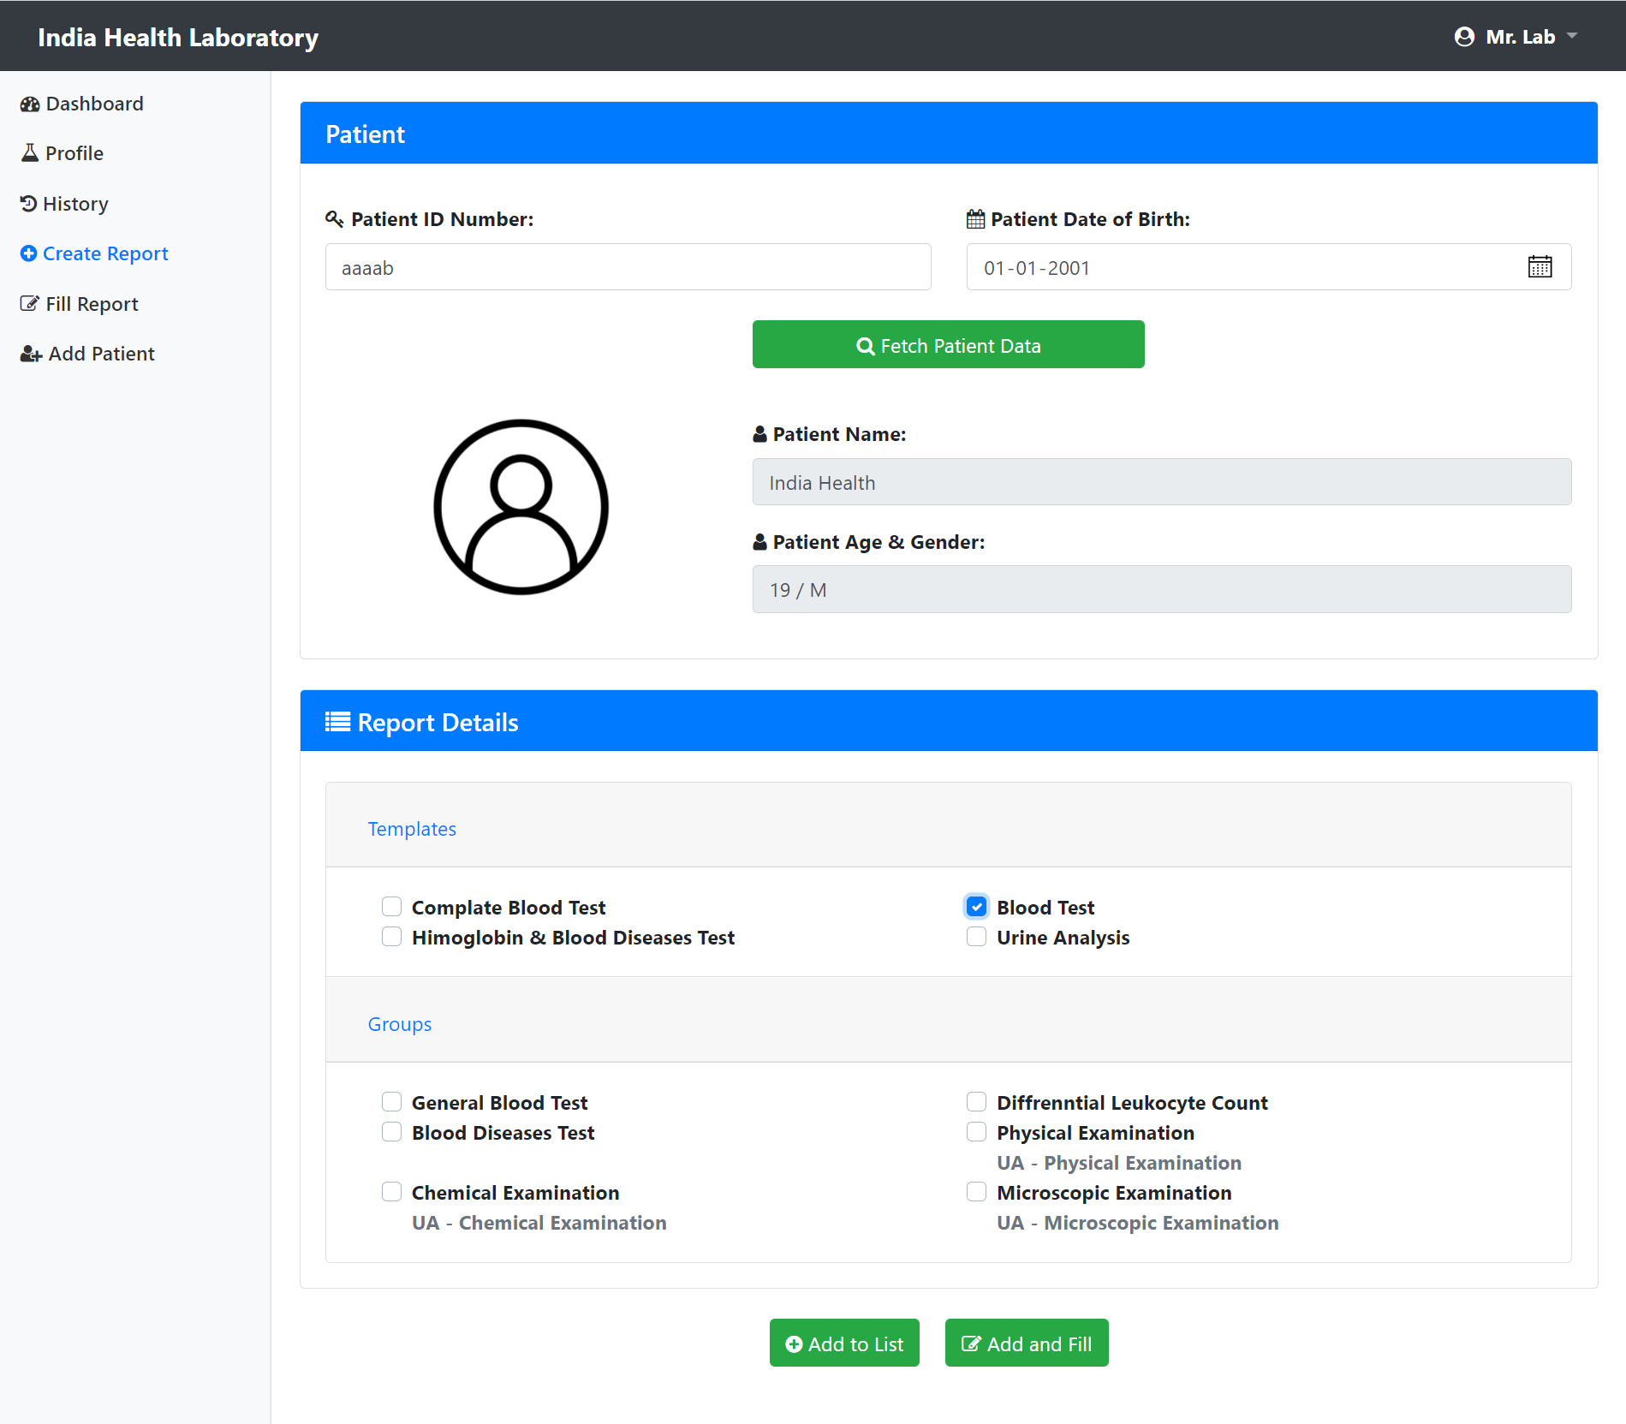

**Screenshots**

**Laboratory – Fill Report**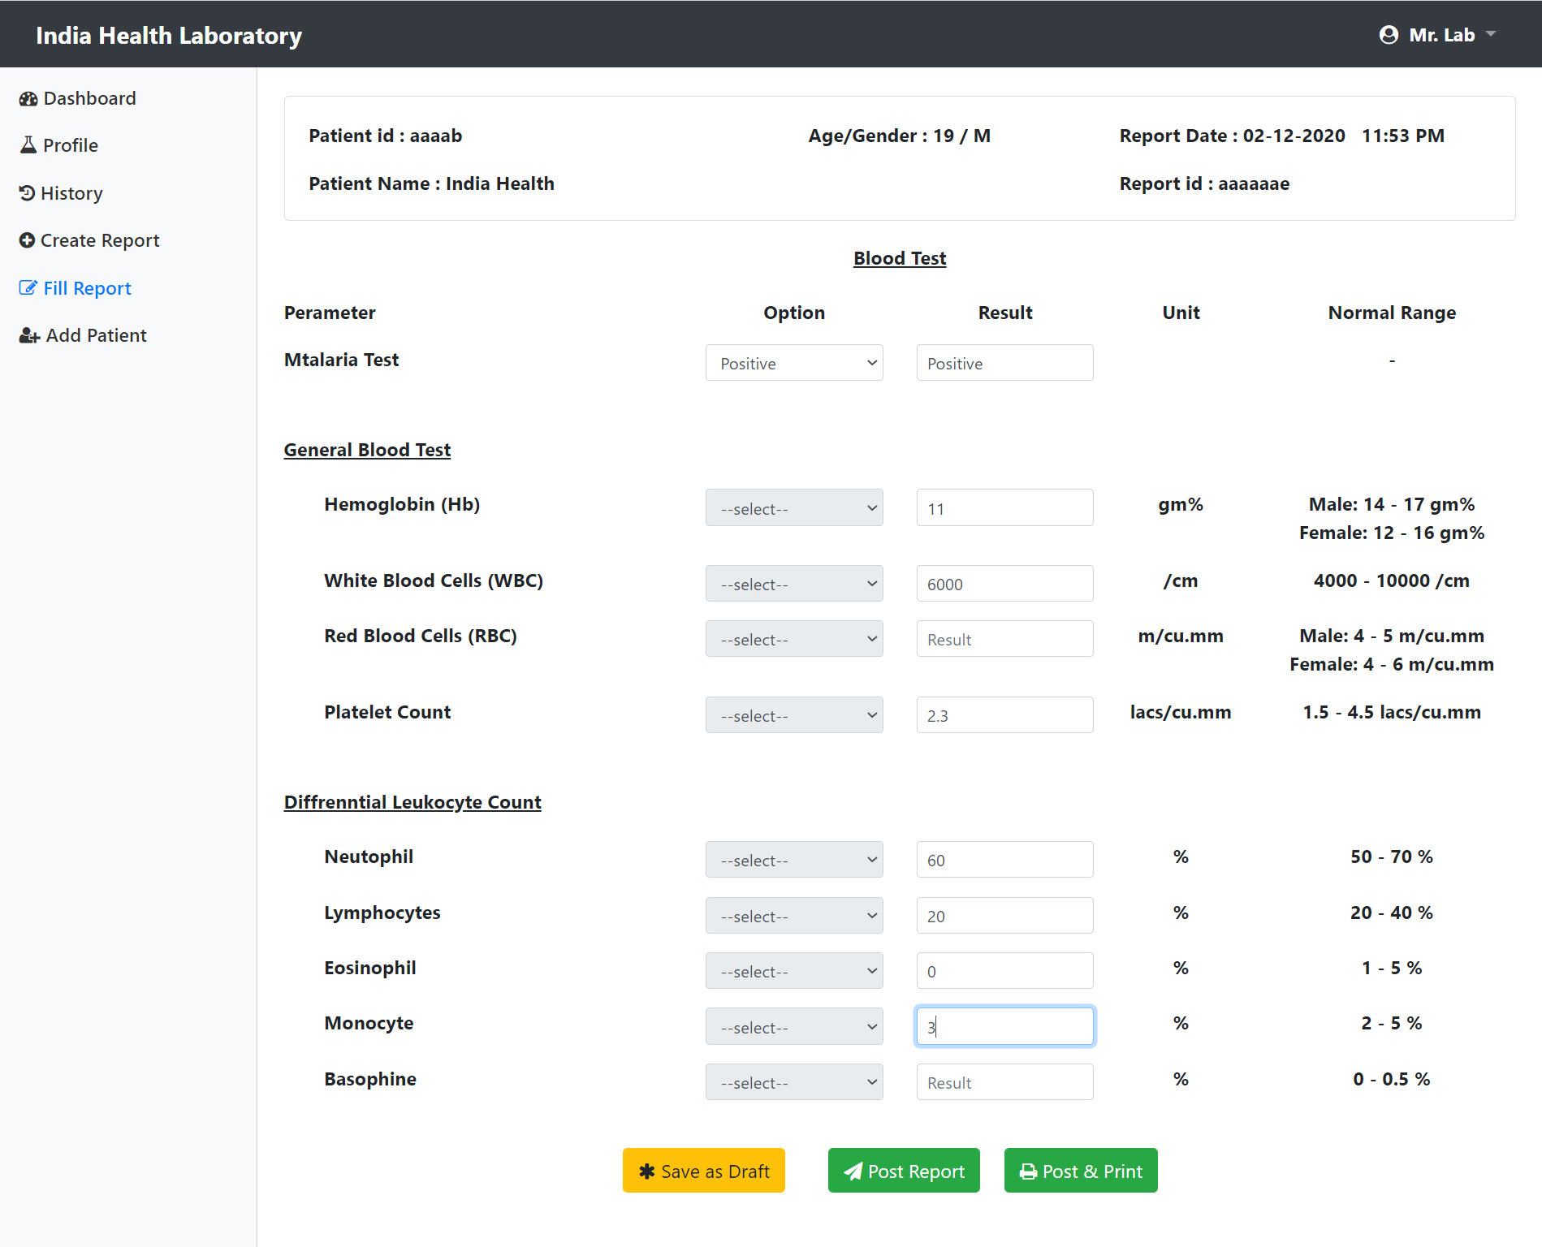

**Screenshots**

**Laboratory – Print Report**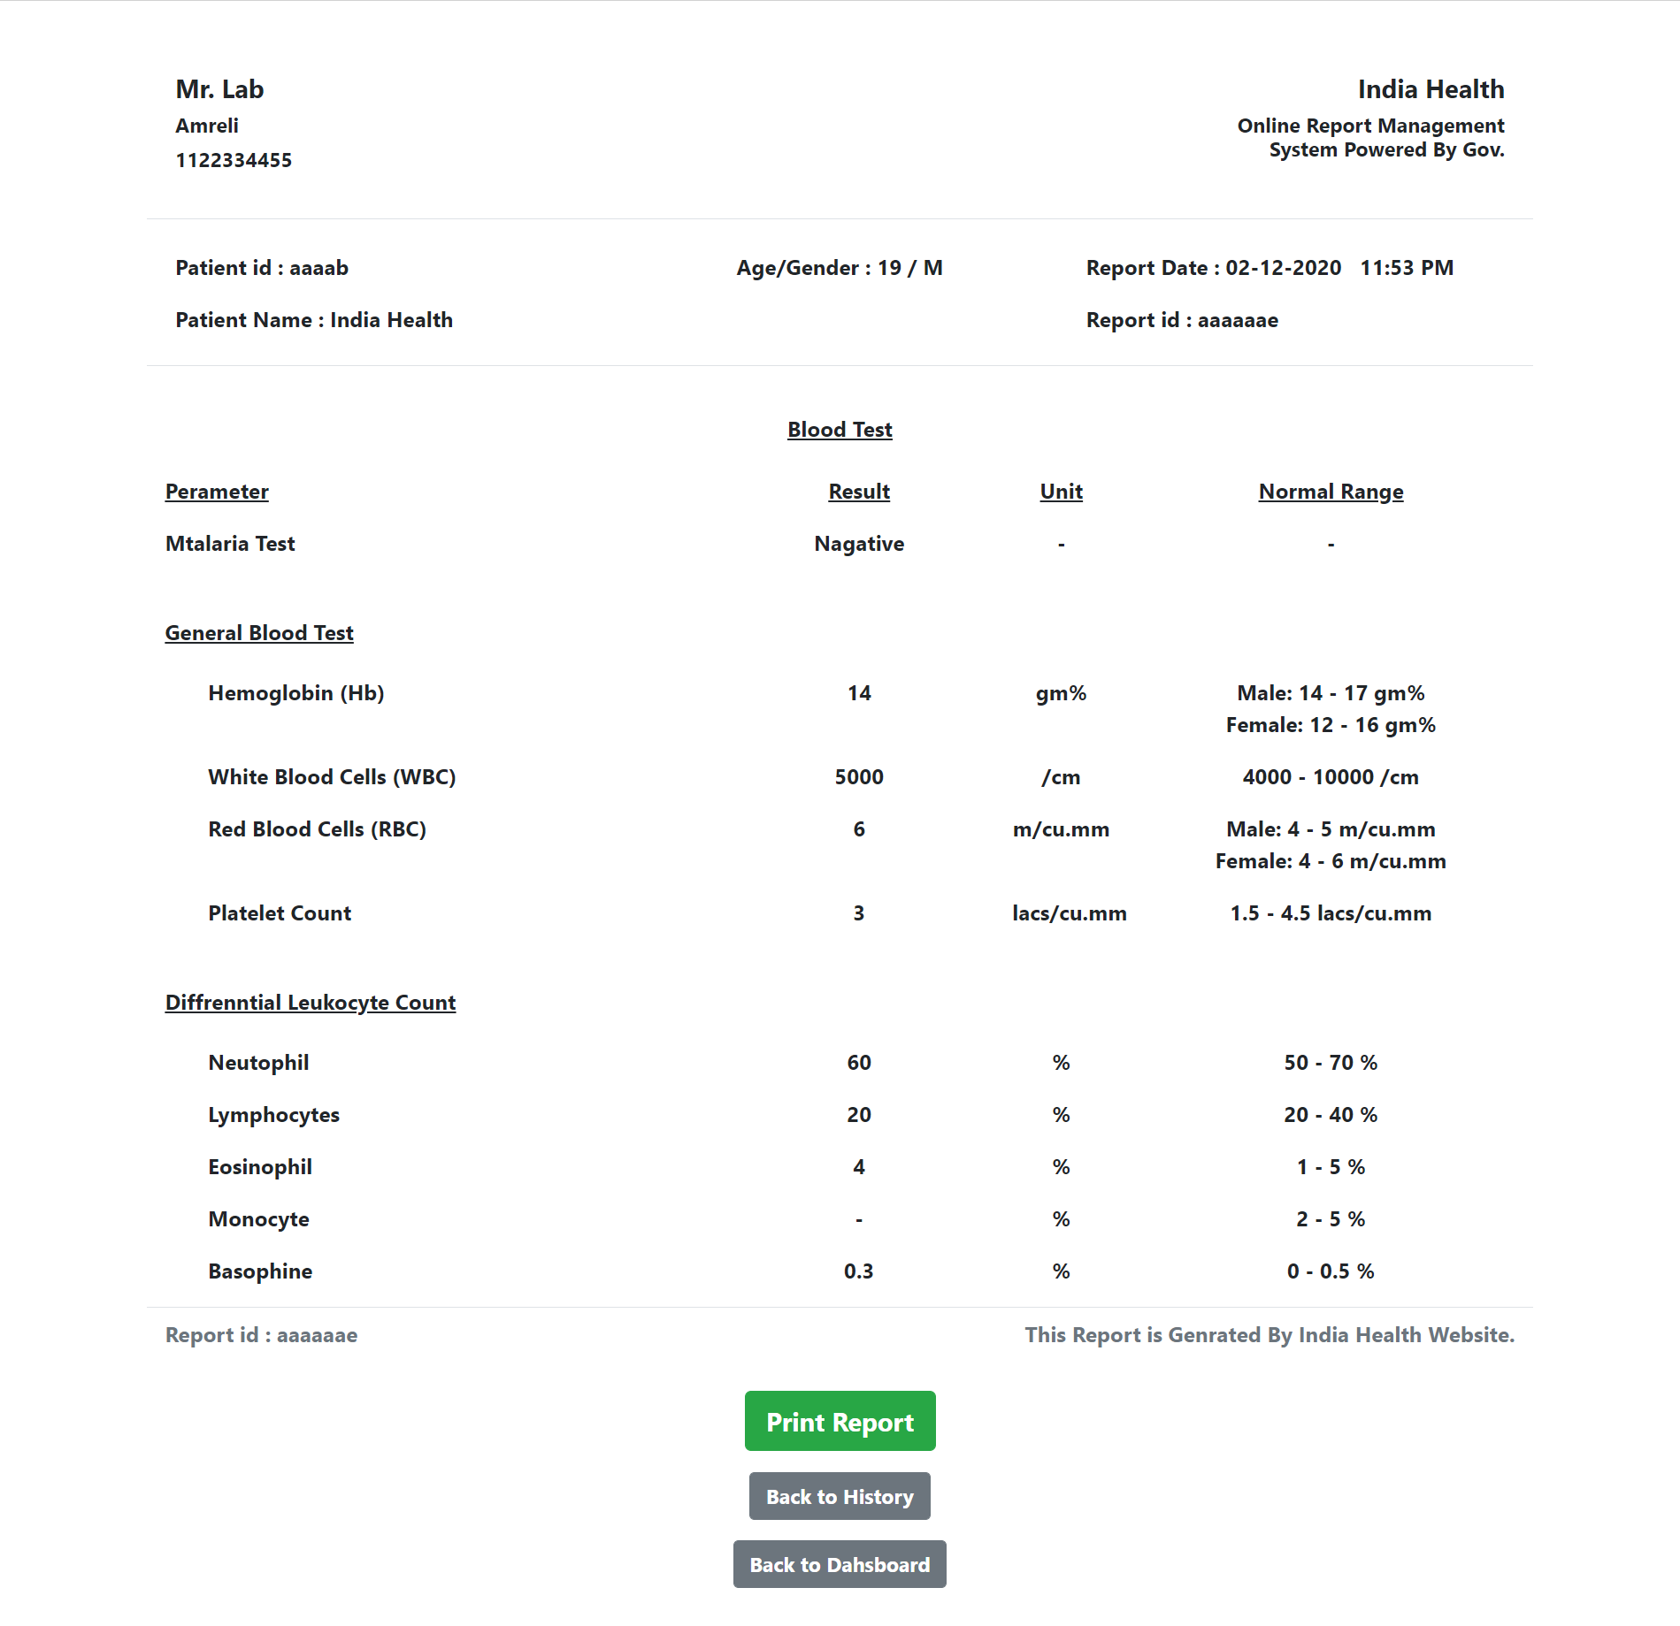

**Screenshots**

**Laboratory – Add Patient**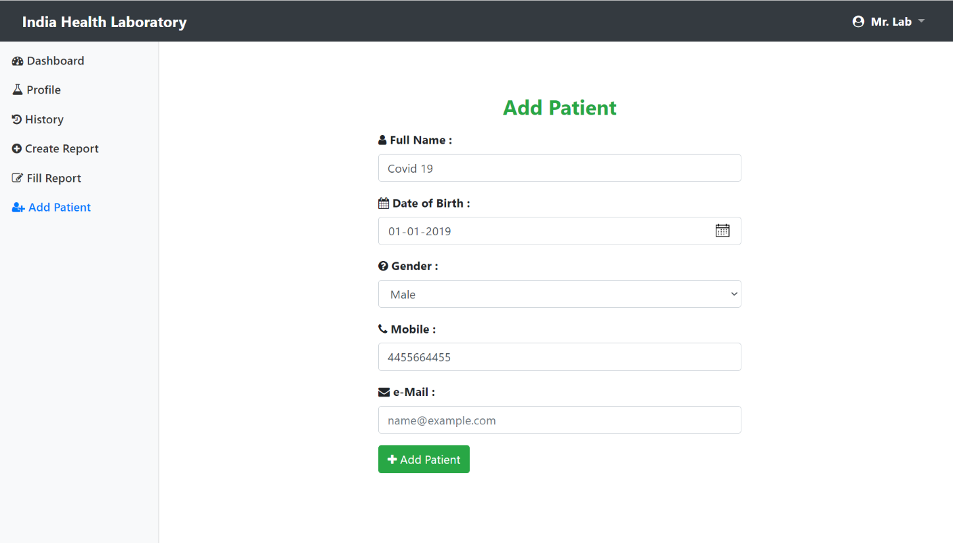

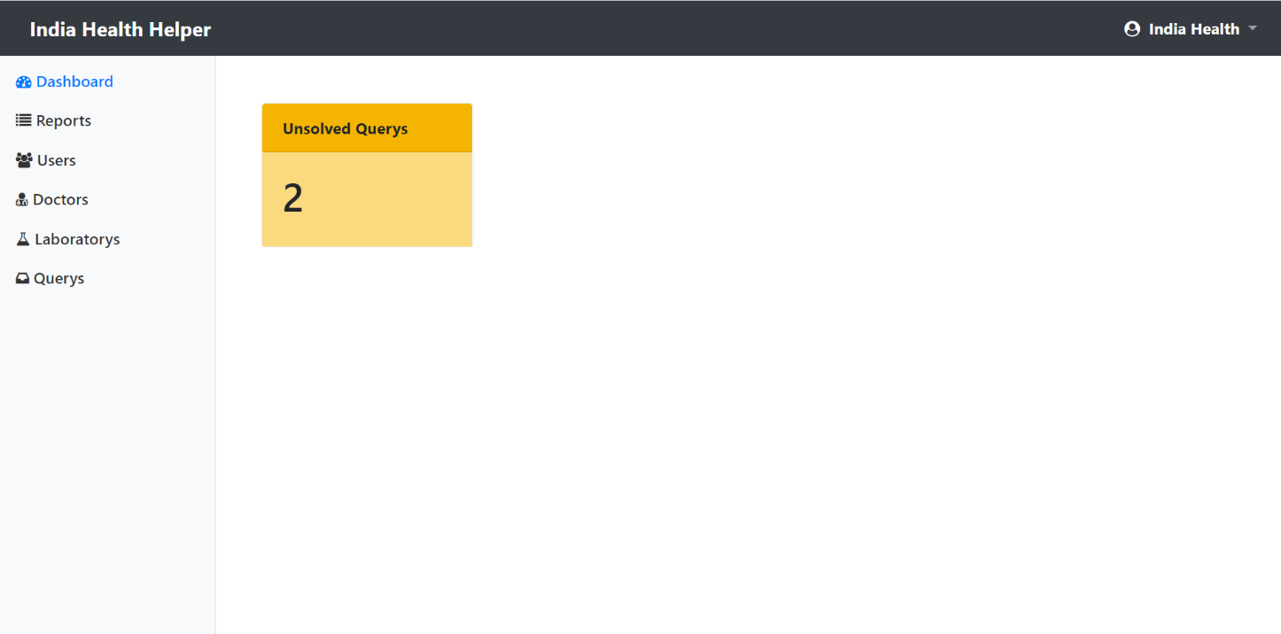**Helper – Dashboard**

**e-Mail Samples**

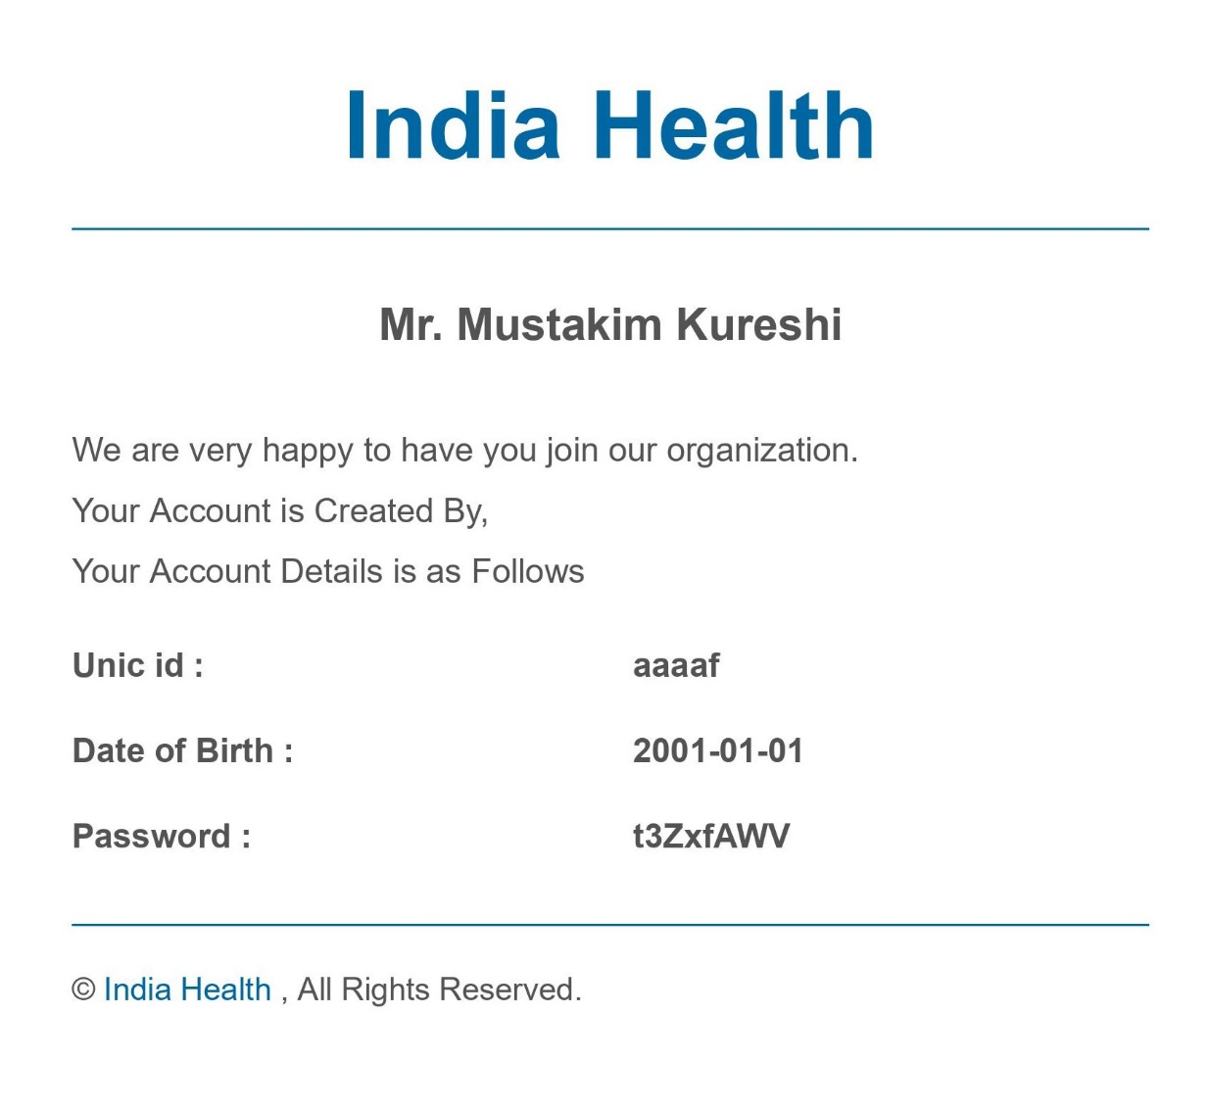

**e-Mail Samples**

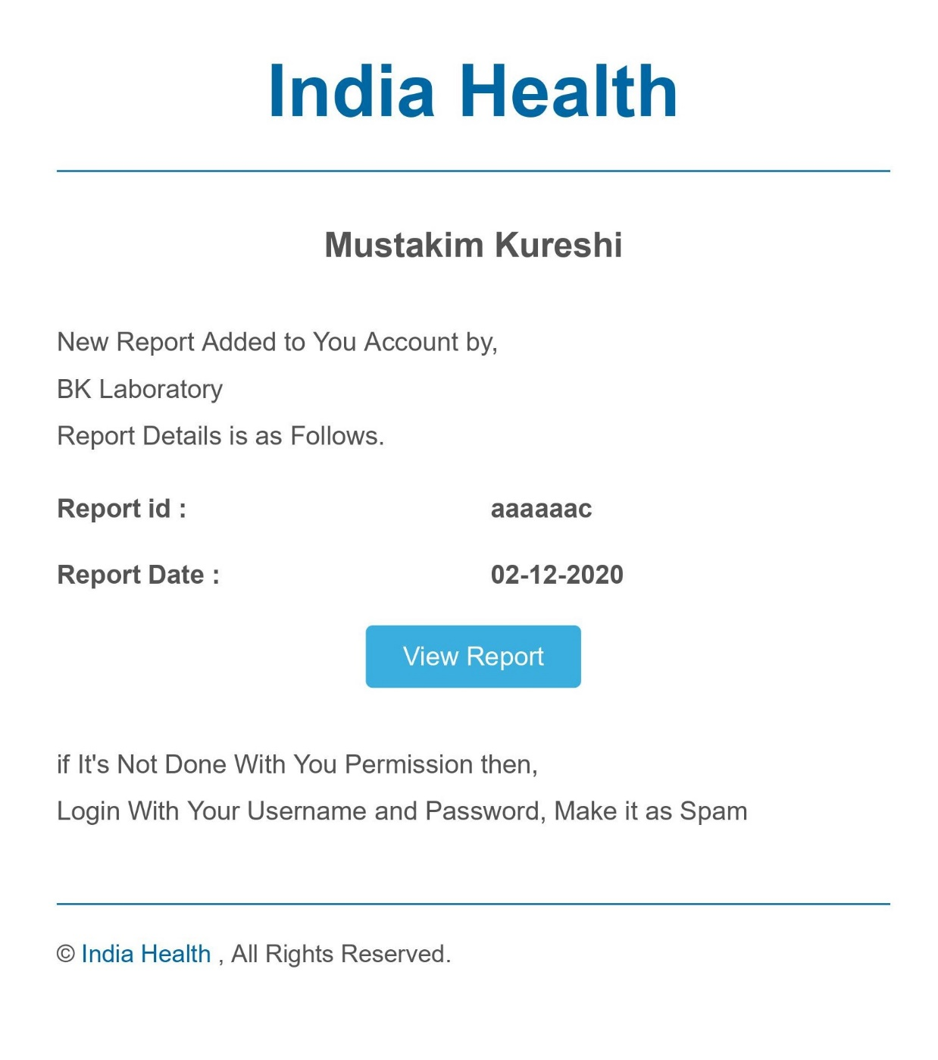

**Future Scope**

The Future Scope of This Website is as Follows.

* + Add Pricing of Reports
  + Give Laboratory to Make Their Own Customize Reports.
  + Patient Can Order Physical Copy of Their Report.
  + Add Report Reminder.
  + Give More Updates to Doctor About Patient Health

**References**

* + [Stack Overflow](https://stackoverflow.com/)
  + [Google](https://www.google.com/)
  + [PHP Manual](https://www.php.net/manual/en/index.php)
  + [W3 Schools](https://www.w3schools.com/)
  + [Bootstrap](https://getbootstrap.com/)
  + Collage Faculties